**Dental Clinic Services System**

Final Progress

Software Requirement Specification

By

**Kanokwan Maneerat 542115002**

**Worapun Wongkium 542115055**

Department of Software Engineering

College of Arts, Media, and Technology

Chiang Mai University

Project Adviser

______________________________

Miss Pattama Longani

**Software Requirement Specification**

**Revision Table**

|  |  |  |  |  |  |
| --- | --- | --- | --- | --- | --- |
| **Document Name** | **Detail** | **Status** | **Date** | **Viewable** | **Reviewer& Responsible** |
| DCSS – SRS - ver 0.1 | All new | Draft | 09/15/2014 | Adviser | Kanokwan & Worapun |
| DCSS – SRS - ver 0.2 | Double check the words | Draft | 09/30/2014 | Adviser | Kanokwan & Worapun |
| DCSS – SRS - ver 0.3 | Delete and add new URS and SRS | Draft | 10/15/2014 | Adviser | Kanokwan & Worapun |
| DCSS – SRS - ver 0.4 | Change some description | Draft | 10/16/2014 | Adviser | Kanokwan & Worapun |
| DCSS – SRS - ver 0.5 | Correct grammar | Draft | 10/17/2014 | Adviser | Kanokwan & Worapun |
| DCSS – SRS - ver 0.6 | Change some URS and renumbering SRS | Draft | 10/19/2014 | Adviser | Kanokwan & Worapun |
| DCSS – SRS - ver 0.7 | Change some URS and renumbering SRS | Draft | 10/20/2014 | Adviser | Kanokwan & Worapun |
| DCSS – SRS - ver 0.8 | Edit some details | Draft | 10/21/2014 | Adviser | Kanokwan & Worapun |
| DCSS – SRS - ver 1.0 | Edit some details | Release | 10/22/2014 | Adviser | Kanokwan & Worapun |
| DCSS – SRS - ver 1.1 | Edit some details | Release | 11/12/2014 | Adviser | Kanokwan & Worapun |

**Table of Contents**

Chapter One: Introduction 5

1. Introduction 5

1.1 Objectives 5

1.2 Project Scope 5

1.3 User Classes and Characteristics 6

Chapter Two: Overall Description 9

2. Overall Description 9

2.1 Product Perspective 9

2.2 Product Features 9

2.3 Design and Implementation Constraints 9

List of project constraints: 9

Chapter Three: User Requirement 10

3. User requirement 10

3.1 Dental clinic services system URS 10

Feature 1: Schedule management 10

Feature 2: Appointment management 10

Feature 3: User registration and authentication 10

Feature 5: Dental care consulting and following up 11

Feature 6: A dental clinic information and promotion 11

Feature 7: Cost estimation of dental treatments 11

4. System Features 19

4.1 User requirement specification with system requirement specification 19

4.2 Use Case Diagram 33

4.2.1 Dental clinic services system Use Case for Patient 33

4.2.2 Dental clinic services system Use Case for Officer 34

4.2.3 Dental clinic services system Use Case for Dentist 37

4.3 Use case description 38

UC-01 Display patients’ own appointment in mobile application 38

UC-02 Display all appointments from Google calendar in mobile application 40

UC-03 Display patients’ own appointment (in website) 42

UC-04 Display dentists’ own appointment (in website) 44

UC-05 Display all appointments from Google calendar 46

UC-06 Display all appointments as list in website 48

UC-07 Display patients’ appointment list for officer 50

UC-08 Display dentists’ appointment for officer 52

UC-09 Display all appointments from Google calendar 54

UC-10 Create new appointment 55

UC-11 Edit appointment 57

UC-12 Delete appointment 59

UC-13 Save the appointment to Google calendar 61

UC-14 Login (in mobile application) 63

UC-15 Login (in website) 64

UC-16 Logout (in mobile application) 66

UC-17 Logout (in website) 67

UC-18 Create new account for patient 68

UC-19 Edit patients’ information 70

UC-20 Delete patients’ account 72

UC-21 Create new account for dentist 74

UC-22 Edit dentists’ information 76

UC-23 Delete dentist s’ account 78

UC-24 Display patients’ list 80

UC-25 Display dentists’ list 82

UC-26 View patients’ information and QR code(mobile) 84

UC-27 View patients’ information and QR code(in website) 86

UC-28 Add patient to a queue 87

UC-29 Reset queue 89

UC-00 91

UC-30 Display his/her follow up message 94

UC-31 Post the question for following up with his/her patient 96

UC-32 Display follow up message 98

UC-33 Answer follow up question 100

UC-34 Display follow up message (mobile application) 102

UC-35 Answer follow up question (mobile application) 104

UC-36 Display dental clinic information and promotion(website) 106

UC-37 Display dental clinic information and promotion (mobile application) 108

UC-38 Add dental clinic information 110

UC-39 Edit dental clinic information 112

UC-40 Delete dental clinic information 114

UC-41 Display dental clinic information and promotion(website) 116

UC-42 Estimate the dental treatment cost (website) 118

UC-43 Estimate the dental treatment cost (mobile application) 120

UC-44 Estimate the dental treatment cost (website) 122

UC-45 Add dental treatment 124

UC-46 Edit dental treatment 126

UC-47 Delete dental treatment 128

UC-48 View dental treatment information 130

# Chapter One: Introduction

## 1. Introduction

### 1.1 Objectives

Dental clinic service system consists of a web application and a mobile application which supports iOS7. The system supports English language for people who are patients, officers, or dentists of dental clinics. Furthermore, it offers some features for visitors who would like to gain information about the clinic. This system will reduce officers’ work and help patients save their time. Patients can find information about the dental clinic and personal information using the mobile application as well as the web application. For the visitor who wants to have a dental treatment from the clinic, and the dentist can use the system for checking their appointment schedule. Dental clinic services system integrates the services that are provided by most dental clinics into the web application and the mobile application. By combining all the services into one, the system provides more convenience to dental clinic users as well as staff.

This Software Requirement Specification has described in more detail of each requirement and each function that the system should have. The document includes the scope of the project, the system’s functionalities, user characteristic, functional requirements, and non-functional requirements.

## 1.2 Project Scope

The objective of this software requirement specification is to specify the requirements that the system should fulfill, which are as follows:

* Dental clinic services system provides an application that is accessible via web browser on a computer and also on a mobile phone.
* Dental clinic services system on mobile phone support iOS.
* Dental clinic services system supports English language only.
* Dental clinic services system provides features for dental clinics’ registered user whose are patients, officers and dentists.
* Dental clinic services system assists managing appointments of patients and dentists using the web application and the mobile application.
* Dental clinic services system provides a user authentication for each patient and dentist through dental clinic officers.
* Dental clinic services system provide features for generate QR code to patients from both web application and mobile application
* Dental clinic services system provide features for managing the queue of dental clinic
* Dental clinic services system assists following up treatment between dentist and patient
* Dental clinic services system provide the feature for promoting the clinic also managing those promotion and information
* Dental clinic services system help visitor and patient to predict the cost of dental care

### 1.3 User Classes and Characteristics

The system divides users into 4 groups. Information and characteristics of each group are listed below.

* **Visitor**

This group of user no needs to register to the system to use the services on the website or to use their mobile phone. Visitor is able to:

* Visitor can view calendar from Google Calendar.
* Visitor can view dental clinic information and promotion
* Visitor can select dental treatment to estimate the cost
* **Patient**

This group of user needs to be registered to the system at the dental clinic. They will get patientID and password from the clinic to use the services on the website or to use their mobile phone. Patients use their patientID to login. Patients are able to:

* Patient can receive a pateintID and password from the dental clinic.
* Patient can login to the web application and the mobile application.
* Patient can logout from the web application and the mobile application.
* Patient can view his/her appointment in the patient schedule.
* Patient can view all appointments in the dental clinic schedule.
* Patient can view their QR code.
* Patient can view follow up question.
* Patient can answer to follow up question.
* Patient can view dental clinic information and promotion.
* Patient can select dental treatment to estimate the cost.
* Patient can identify him/herself by using the QR code
* **Officer**

This group of users has the highest privilege in the system. They are given access to management functions for maintaining the system. Officers are able to:

* Officer can login to the web application using officerID and password.
* Officer can logout from the web application.
* Officer can register for new patients and dentists.
* Officer can add an appointment into the dental clinic schedule.
* Officer can edit an appointment in the dental clinic schedule.
* Officer can delete an appointment in the dental clinic schedule.
* Officer can add patient to a queue and reset queue.
* Officer can add information and promotion into the website.
* Officer can edit information and promotion from the website.
* Officer can delete information and promotion from the website.
* Officer can add dental treatment and cost into the website.
* Officer can edit dental treatment and cost from the website.
* Officer can delete dental treatment and cost from the website.
* Officer can view all dental treatment.
* Officer can view patients’ identification result.

**Dentist**

This group of user needs to be registered to the system at the dental clinic. They will register their account at the clinic. Dentist uses their dentistID and password to login to the system to use the services. Dentists are able to:

* Dentist can login to the web application by using dentistID and password
* Dentist can logout from the web application
* Dentist can view his/her appointments in the dentist schedule
* Dentist can view all appointments in the dental clinic schedule
* Dentist can view their follow up question.
* Dentist can post question to follow up their patient

2. **1.4 Operation Environment**

Dental clinic services system uses web service technology and iOS technology. All the characters must have the Internet connection. Patients who want to use the mobile application must use a smartphone which supports iOS7.

**1.5** **Acronyms and Definitions Acronyms**

**Acronyms**

|  |  |
| --- | --- |
| **Acronyms** | **Stands for** |
| Registered User | Patient, Dentist, and Officer |
| Non-registered User | Visitor |
| PSR | Project Status Report |
| PM | Project Management |
| PMP | Project Management Plan |
| URS | User Requirement Specification |
| SRS | Software Requirement Specification |
| VSE | Very Small Entity |
| QR code | Quick Response Code |
| UC | Use Case |
| AD | Activity Diagram |
| UI | User Interface |
| UTC | Unit Test Case |
| STC | System Test Case |
| CD | Class Diagram |
| SD | Sequence Diagram |

# 

# Chapter Two: Overall Description

## 2. Overall Description

### 2.1 Product Perspective

The Dental clinic services system consists of a mobile application base on iOS and a web application. The system helps patients save their time to contact the dental clinic by providing features such as making an appointment, viewing upcoming appointment, and getting cost estimation. It helps dentist to follow up their patients and check their appointments and schedule. Also the system reduces works of officers by providing them with features such as using QR code to identify patients at the clinic, managing appointments for patients and dentists. This system combines most of dental clinics' services into one application.

### 2.2 Product Features

The dental clinic services system offers seven features.

* Feature 1: Schedule management
* Feature 2: User registration and authentication
* Feature 3: Appointment management
* Feature 4: Patient identification using QR code
* Feature 5: Dental care consulting and following up
* Feature 6: A dental clinic information and promotion
* Feature 7: Cost estimation of dental treatments

Each of features will create a step-by-step suit by priority. In this progress we will develop Feature 4, 5, 6, and 7

### 2.3 Design and Implementation Constraints

### List of project constraints:

* The application works only on iOS version7.
* The application requires the Internet connection.
* The application is available for users who are already registered to the system to use all the services and who are not registered to the system will be a visitor whose can be able to use only some services.

# Chapter Three: User Requirement

## 3. User requirement

## 3.1 Dental clinic services system URS

#### Feature 1: Schedule management

1. URS-01: Patient can view own appointment in mobile application
2. URS-02: Patient can view all appointments from Google calendar in mobile application
3. URS-03: Patient can view own appointment in website
4. URS-04: Dentist can view own appointment in website
5. URS-05: Visitor can view all appointments from Google calendar in website
6. URS-06: Officer can view all appointments as a list in website
7. URS-07: Officer can view patients’ appointment as a list in website
8. URS-08: Officer can view dentists’ appointment as a list in website
9. URS-09: Registered User can view all appointments from Google calendar in website

#### Feature 2: Appointment management

URS-10: Officer can create a new appointment

URS-11: Officer can edit the appointment

URS-12: Officer can delete the appointment

URS-13: Officer can save the appointment to Google calendar

#### Feature 3: User registration and authentication

URS-14: Patient can login to the mobile application

URS-15: Registered User can login to the website

URS-16: Patient can logout from the mobile application

URS-17: Registered User can logout from the website

URS-18: Officer can create an account for new patient

URS-19: Officer can edit patients’ information

URS-20: Officer can delete patients’ account

URS-21: Officer can create an account for new dentist

URS-22: Officer can edit dentists’ information

URS-23: Officer can delete dentists’ account

URS-24: Officer can view all patients’ account as a list

USR-25: Officer can view all dentists’ account as a list

**Feature 4: Patient identification using QR code**

* URS-26: Patient can view their QR code from mobile application
* URS-27: Patient can view their QR code from website
* URS-28: Officer can add patient to a queue
* URS-29: Officer can reset queue
* URS-30: Officer can view patients’ identification result

## Feature 5: Dental care consulting and following up

* URS-31: Dentist can view his/her patient follow up message as a list
* URS-32: Dentist can post question to follow up his/her patient
* URS-33: Patient can view follow up massage that his/her dentist asked in the

websiteas a list

* URS-34: Patient can answer follow up massage that his/her dentist asked in the

websiteas a list

* URS-35: Patient can view follow up massage that his/her dentist asked in mobile

applicationas a list

* URS-36: Patient can answer view follow up massage that his/her dentist asked in

mobile applicationas a list

## Feature 6: A dental clinic information and promotion

* URS-37: Patient can view the dental clinic information and promotion in the
* website
* URS-38: Patient can view the dental clinic information and promotion in mobile
* application
* URS-39: Officer can add the information and promotion to the database
* URS-40: Officer can edit the dental clinic information and promotion in the
* database
* URS-41: Officer can delete the dental clinic information and promotion from the
* database
* URS-42: Visitor can view the dental clinic information and promotion

## Feature 7: Cost estimation of dental treatments

* URS-43: Patient can select the dental treatment to estimate the cost by his/herself
* in the website
* URS-44: Patient can select the dental treatment to estimate the cost by his/herself
* in the mobile application
* URS-45: Visitor can select the dental treatment to estimate the cost by his/herself
* in the website
* URS-46: Officer can add dental treatment information including the detail and
* cost into the database
* URS-47: Officer can edit dental treatment information including the detail and
* cost in the database
* URS-48: Officer can delete dental treatment information from the database
* URS-49: Officer can view dental treatment information as a list
* **SRS-01:** System shall connect with the dentalclinic database
* **SRS-02:** System shall retrieve patients’ appointment data including appointmentID, patientID, dentistID, appointment date, start time, end time, dental treatment, and description from database
* **SRS-03:** System shall provide patients’ appointment data from the database in appointment page in mobile application
* **SRS-04:** System shall provide appointment calendar from Google calendar in appointment calendar page in the website
* **SRS-05:** System shall provide appointment calendar form Google calendar in calendar page in mobile application
* **SRS-06:** System shall provide patients’ appointment data from the database in patient appointment page in the website
* **SRS-07:** System shall retrieve dentists’ appointment data including appointmentID, patientID, dentistID, appointment date, start time, end time, dental treatment, and description from database
* **SRS-08:** System shall provide dentists’ appointment data from the database in dentist appointment page in the website
* **SRS-09:** System shall retrieve all appointments’ data including appointmentID, patientID, dentistID, appointment date, start time, end time, dental treatment, and description from database
* **SRS-10:** System shall provide all appointments’ data as a list from the database in all appointment page
* **SRS-11:** System shall provide patients’ appointment data from the database in patient appointment page (for officer) in the website
* **SRS-12:** System shall provide dentists’ appointment data from the database in dentist appointment page (for officer) in the website
* **SRS-13:** System shall provide create appointment page in the website
* **SRS-14:** System shall add appointments’ data including patientID, dentistID, appointment date, start time, end time, dental treatment, and description into the database
* **SRS-15:** System shall update appointment table in the database
* **SRS-16:** System shall provide appointments’ edit page in the website
* **SRS-17:** System shall edit appointments’ data in appointment table in the database
* **SRS-18:** System shall delete appointments’ data in appointment table in the database
* **SRS-19:** System shall redirect to Google calendar page
* **SRS-20:** System shall provide appointments’ data from the database in Google calendar form in Google website
* **SRS-21:** System shall save appointments’ data into the Google calendar
* **SRS-22:** System shall provide patient login page in the website
* **SRS-23:** System shall validate patientID and password from input form matching with the data in patient table in the database
* **SRS-24:** System shall redirect to patient login page if login fail
* **SRS-25:** System shall redirect to index page in the website
* **SRS-26:** System shall store session after login success
* **SRS-27:** System shall provide patient login page in mobile application
* **SRS-28:** System shall display error message if there are empty fields “Please input patientID and password” in mobile application
* **SRS-29:** System shall display error message if login fail “You’re login fail” in mobile application
* **SRS-30:** System shall redirect to index page in mobile application
* **SRS-31:** System shall destroy session
* **SRS-32:** System shall provide create patient account page in the website
* **SRS-33:** System shall add patients’ data including patientID, password, first name, last name, age, gender, address, tel., email, and treatment into the database
* **SRS-34:** System shall update patient table in the database
* **SRS-35:** System shall provide patients’ edit page in the website
* **SRS-36:** System shall edit patients’ information in patient table in the database
* **SRS-37:** System shall delete patients’ account in patient table in the database
* **SRS-38:** System shall retrieve patients’ data including patientID, password, first name, last name, age, gender, address, tel., email, and treatment from the database
* **SRS-39:** System shall provide patients’ data as a list in the patient list page
* **SRS-40:** System shall provide create dentist account page in the website
* **SRS-41:** System shall add dentists’ data including dentistID, password, first name, last name, address, email, and tel. into the database
* **SRS-42:** System shall update dentist table in the database
* **SRS-43:** System shall provide dentists’ edit page in the website
* **SRS-44:** System shall edit dentists’ information in dentist table in the database
* **SRS-45:** System shall delete dentists’ account in dentist table in the database
* **SRS-46:** System shall retrieve dentists’ data including dentistID, password, first name, last name, email, and tel. from the database
* **SRS-47:** System shall provide dentists’ data as a list in the dentist list page
* **SRS-48:** System shall display alert message “Invalid patientID or password”
* **SRS-49:** System shall display alert message “Invalid officerID or password”
* **SRS-50:** System shall display alert message “Invalid dentistID or password”
* **SRS-51:** System shall retrieve all patients’ appointment data including appointmentID, patientID, dentistID, appointment date, start time, end time, dental treatment, and description from database
* **SRS-52:** System shall retrieve all dentists’ appointment data including appointmentID, patientID, dentistID, appointment date, start time, end time, dental treatment, and description from database
* **SRS-53:** System shall redirect to dentist login page if login fail
* **SRS-54:** System shall redirect to officer login page if login fail
* **SRS-55:** System shall validate dentistID and password from input form matching with the data in dentist table in the database
* **SRS-56:** System shall validate officerID and password from input form matching with the data in officer table in the database
* **SRS-57:** System shall retrieve appointments’ data including including appointmentID, patientID, dentistID, appointment date, start time, end time, dental treatment, and description from database
* **SRS-58**: System shall provide appointments’ data in appointment edit page
* **SRS-59:** System shall show error message “Please fill out this field” for any field that requires being not empty
* **SRS-60:** System shall show error message “Duplicate data”
* **SRS-61:** System shall generate the patient’s QR code in mobile application
* **SRS-62:** System shall provide the patient’s QR code in the website
* **SRS-63:** System shall provide the dent follow up page in the website
* **SRS-64:** System shall provide the follow up form in the dent follow up page in the website
* **SRS-65:** System shall provide the follow up page in the mobile application
* **SRS-66:** System shall provide the answer follow up form in the follow up page in the mobile application
* **SRS-67:** System shall retrieve the follow up’s data including patientID, dentistID, question, answer, question time, and answer time from followup table the dentalclinic database
* **SRS-68:** System shall provide the follow up’s data including question, answer, question time, and answer time as a list from followup table the dentalclinic database into the dent follow up page in website
* **SRS-69:** System shall add the patient’s message data including answer into the followup database in the dentalclinic database
* **SRS-70:** System shall add the dentist’s message data including question and answer into the dentalclinic database
* **SRS-71:** System shall update follow up table in the dentalclinic database
* **SRS-72:** System shall provide the follow up’s data including question, answer, question time, and answer time as a list from followup table the dentalclinic database into the follow up page in mobile application
* **SRS-73:** System shall retrieve the dental information’s data or promotion’s data including infoID, title, and details from the information table in the
* **SRS-74:** System shall provide the dental information’s data or promotion’s data including infoID, title, and details from the information table in the dentalclinic database into the edit information and promotion form
* **SRS-75:** System shall provide the dental clinic information and promotion’s data including title and details from information table in the dentallcinic database into the information and promotion page in in the website
* **SRS-76:** System shall provide the create dental treatment page
* **SRS-77:** System shall provide the dental clinic information and promotin’s data including title and details from information table in the dentallcinic database into the information and promotion page in the website
* **SRS-78:** System shall provide the dental clinic information and promotion’s data including title and details from information table in the dentallcinic database into the information and promotion page in the mobile application
* **SRS-79:** System shall provide the create information and promotion page
* **SRS-80:** System shall add dental clinic information’s data or promotion’s data including type, title and details into the information table in dentalclinic database
* **SRS-81:** System shall update information table in the dentalclinic database
* **SRS-82:** System shall edit dental clinic information’s data or promotion’s data which are type, title, and details in information and promotion table in the dentalclinic database
* **SRS-83:** System shall delete dental clinic information’s data or promotion’s data from information in the dentallcinic database
* **SRS-84:** System shall provide the dental information and promotion as a list including title and details from information table in the dentalclinic database into all information and promotion page
* **SRS-85:** System shall provide the cost estimation page in website
* **SRS-86:** System shall provide the cost estimation page in mobile application
* **SRS-87:** System shall retrieve the dental treatments’ data including treatmentID, dental treatment name, treatment cost from the treatment table in dentalclinic database
* **SRS-88:** System shall provide the dental treatment’s data as a list including treatmentID, dental treatment name, treatment cost from the treatment table in dentalclinic database into the cost estimation page in website
* **SRS-89:** System shall calculate the cost of dental treatment by using the treatment cost that user selected
* **SRS-90:** System shall provide the totally cost of dental treatment that the user selected in the cost estimation page
* **SRS-91:** System shall provide the dental treatment’s data as a list including treatmentID, dental treatment name, treatment cost from the treatment table in dentalclinic database into the cost estimation page in mobile application
* **SRS-92:** System shall add the dental treatment information data including dental treatment name, treatment cost into the treatment table in the dentalclinic database
* **SRS-93:** System shall update the dental treatment table in the dentalclinic database
* **SRS-94:** System shall edit dental treatment’s data, which are treatmentID, treatment name, treatment cost in dental treatment table in the dentalclinic database
* **SRS-95:** System shall delete dental clinic treatment’s data from dental treatment table in the dentalclinic database
* **SRS-96:** System shall provide the dental treatment’s data including treatmentID, dental treatment name, treatment cost from the treatment table in dentalclinic database into the dental treatment edit form
* **SRS-97:** System shall provide the patient follow up page in the website
* **SRS-98:** System shall provide the follow up form in the patient follow up page in the website
* **SRS-99:** System shall provide the follow up’s data including question, answer, question time, and answer time as a list from followup table the dentalclinic database into the follow up page in website
* **SRS-100:** System shall return true if the question is already save
* **SRS-101:** System shall return false if the question is not saved yet
* **SRS-102:** System shall return true if the answer is already save
* **SRS-103:** System shall return false if the answer is not saved yet
* **SRS-104:** System shall provide the dental treatment data as a list in that is including with treatmentID, treatment name and treatment cost in all dental treatment pages
* **SRS-105:** System shall provide the patients’ information including QR code in view information page in mobile application
* **SRS-106:** System shall provide the patients’ information including QR code in view information page in the website
* **SRS-107:** System shall provide page for checking an appointment date and time
* **SRS-108:** System shall check time of input patientID and return the time of appointment
* **SRS-109:** System shall check time of input patientID and return “Not today” for not match date
* **SRS-110:** System shall check time of input patientID and return “No appointment” for the patientID that are not appointed
* **SRS-111:** System shall check time of input patientID and return “You’re missed” for the patientID that are late
* **SRS-112:**  System shall provide check time result page
* **SRS-113:** System shall provide the add queue page to add patient to a queue
* **SRS-114:** System shall add patient into a queue
* **SRS-115:** System shall shift patient to a next queue
* **SRS-116:** System shall provide the add queue page to add patient to a queue
* **SRS-117:** System shall provide the page for reset a queue
* **SRS-118:** System shall set all queue to be empty
* **SRS-119:** System shall retrieve the patient’s appointment data from appointment table that including patientID, dentistID, appointment date, start time, end time, treatment and description from dentalclinic database
* **SRS-120:** System shall provide the patient’s appointment data from appointment table that including patientID, dentistID, appointment date, start time, end time, treatment and description from dentalclinic database in the patient appointment page
* **SRS-121:** System shall provide the follow up’s data including question, answer, question time, and answer time into the answer follow up form in follow up page in the website
* **SRS-122:** System shall provide the follow up’s data including question, answer, question time, and answer time into the answer follow up form in follow up page in the mobile application

**SRS-123:** System shall redirect to the own patient personal information page

**Chapter Four: System Features**

## 4. System Features

### 4.1 User requirement specification with system requirement specification

#### URS-01: Patient can view own appointment in mobile application

**SRS-01:** System shall connect with the dentalclinic database

**SRS-02:** System shall retrieve patients’ appointment data including appointmentID, patientID, dentistID, appointment date, start time, end time, dental treatment, and description from database

**SRS-03:** System shall provide patients’ appointment data from the database in appointment page in mobile application

#### URS-02: Patient can view all appointments from Google calendar in mobile application

**SRS-05:** System shall provide appointment calendar form Google calendar in calendar page in mobile application

#### URS-03: Patient can view own appointment in website

**SRS-01:** System shall connect with the dentalclinic database

**SRS-02:** System shall retrieve patients’ appointment data including appointmentID, patientID, dentistID, appointment date, start time, end time, dental treatment, and description from database

**SRS-06:** System shall provide patients’ appointment data from the database in patient appointment page in the website

#### URS-04: Dentist can view own appointment in website

**SRS-01:** System shall connect with the dentalclinic database

**SRS-07:** System shall retrieve dentists’ appointment data including appointmentID, patientID, dentistID, appointment date, start time, end time, dental treatment, and description from database

**SRS-08:** System shall provide dentists’ appointment data from the database in dentist appointment page in the website

#### URS-05: Visitor can view all appointment from Google calendar

**SRS-04:** System shall provide appointment calendar from Google calendar in appointment calendar page in the website

#### URS-06: Officer can view all appointments as a list in website

**SRS-01:** System shall connect with the dentalclinic database

**SRS-09:** System shall retrieve all appointments’ data including appointmentID, patientID, dentistID, appointment date, start time, end time, dental treatment, and description from database

**SRS-10:** System shall provide all appointments’ data as a list from the database in all appointment page

#### URS-07: Officer can view patients’ appointment as a list in website

**SRS-01:** System shall connect with the dentalclinic database

**SRS-11:** System shall provide patients’ appointment data from the database in patient appointment page (for officer) in the website

**SRS-38:** System shall retrieve patients’ data including patientID, password, first name, last name, age, gender, address, tel., email, and treatment from the database

**SRS-39:** System shall provide patients’ data as a list in the patient list page

**SRS-51:** System shall retrieve all patients’ appointment data including appointmentID, patientID, dentistID, appointment date, start time, end time, dental treatment, and description from database

#### URS-08: Officer can view dentists’ appointment as a list in website

**SRS-01:** System shall connect with the dentalclinic database

**SRS-12:** System shall provide dentists’ appointment data from the database in dentist appointment page (for officer) in the website

**SRS-46:** System shall retrieve dentists’ data including dentistID, password, first name, last name, email, and tel. from the database

**SRS-47:** System shall provide dentists’ data as a list in the dentist list page

**SRS-52:** System shall retrieve all dentists’ appointment data including appointmentID, patientID, dentistID, appointment date, start time, end time, dental treatment, and description from database

**URS-09: Registered User can view all appointments from Google calendar in website**

**SRS-04:** System shall provide appointment calendar from Google calendar in appointment calendar page in the website

#### URS-10: Officer can create new appointment

**SRS-01:** System shall connect with the dentalclinic database

**SRS-10:** System shall provide all appointments’ data as a list from the database in all appointment page

**SRS-13:** System shall provide create appointment page in the website

**SRS-14:** System shall add appointments’ data including patientID, dentistID, appointment date, start time, end time, dental treatment, and description into the database

**SRS-15:** System shall update appointment table in the database

**SRS-59:** System shall show error message “Please fill out this field” for any field that requires being not empty

**SRS-60:** System shall show error message “Duplicate data”

#### URS-11: Officer can edit the appointment

**SRS-01:** System shall connect with the dentalclinic database

**SRS-09:** System shall retrieve all appointments’ data including appointmentID, patientID, dentistID, appointment date, start time, end time, dental treatment, and description from database

**SRS-10:** System shall provide all appointments’ data as a list from the database in all appointment page

**SRS-16:** System shall provide appointments’ edit page in the website

**SRS-15:** System shall update appointment table in the database

**SRS-17:** System shall edit appointments’ data in appointment table in the database

**SRS-57:** System shall retrieve appointments’ data including including appointmentID, patientID, dentistID, appointment date, start time, end time, dental treatment, and description from database

**SRS-58**: System shall provide appointments’ data in appointment edit page

**SRS-59**: System shall show error message “Please fill out this field” for any field that requires being not empty

#### URS-12: Officer can delete the appointment

**SRS-01:** System shall connect with the dentalclinic database

**SRS-09:** System shall retrieve all appointments’ data including appointmentID, patientID, dentistID, appointment date, start time, end time, dental treatment, and description from database

**SRS-10:** System shall provide all appointments’ data as a list from the database in all appointment page

**SRS-15:** System shall update appointment table in the database

**SRS-18:** System shall delete appointments’ data in appointment table in the database

#### URS-13: Officer can save the appointment to Google calendar

**SRS-01:** System shall connect with the dentalclinic database

**SRS-09:** System shall retrieve all appointments’ data including appointmentID, patientID, dentistID, appointment date, start time, end time, dental treatment, and description from database

**SRS-10:** System shall provide all appointments’ data as a list from the database in all appointment page

**SRS-19:** System shall redirect to Google calendar page

**SRS-20:** System shall provide appointments’ data from the database in Google calendar form in Google website

**SRS-21:** System shall save appointments’ data into the Google calendar

#### URS-14: Patient can login to the mobile application

**SRS-01:** System shall connect with the dentalclinic database

**SRS-23:** System shall validate patientID and password from input form matching with the data in patient table in the database

**SRS-24:** System shall redirect to patient login page if login fail

**SRS-26:** System shall store session after login success

**SRS-27:** System shall provide patient login page in mobile application

**SRS-28:** System shall display error message if there are empty fields “Please input patientID and password” in mobile application

**SRS-29:** System shall display error message if login fail “You’re login fail” in mobile application

**SRS-30:** System shall redirect to index page in mobile application

#### URS-15: Registered User can login to the website

**SRS-01:** System shall connect with the dentalclinic database

**SRS-22:**  System shall provide patient login page in the website

**SRS-23:** System shall validate patientID and password from input form matching with the data in patient table in the database

**SRS-24:** System shall redirect to patient login page if login fail

**SRS-25:** System shall redirect to index page in the website

**SRS-26:** System shall store session after login success

**SRS-48:** System shall display alert message “Invalid patientID or password”

**SRS-49:** System shall display alert message “Invalid officerID or password”

**SRS-50:** System shall display alert message “Invalid dentistID or password”

**SRS-53:** System shall redirect to dentist login page if login fail

**SRS-54:** System shall redirect to officer login page if login fail

**SRS-55:** System shall validate dentistID and password from input form matching with the data in dentist table in the database

**SRS-56:** System shall validate officerID and password from input form matching with the data in officer table in the database

#### URS-16: Patient can logout from the mobile application

**SRS-01:** System shall connect with the dentalclinic database

**SRS-30:** System shall redirect to index page in mobile application

**SRS-31:** System shall destroy session

#### URS-17: Registered User can logout from the website

**SRS-01:** System shall connect with the dentalclinic database

**SRS-25:** System shall redirect to index page in the website

**SRS-31:** System shall destroy session



#### URS-18: Officer can create an account for new patient

**SRS-01:** System shall connect with the dentalclinic database

**SRS-32:** System shall provide create patient account page in the website

**SRS-33:** System shall add patients’ data including patientID, password, first name, last name, age, gender, address, tel., email, and treatment into the database

**SRS-34:** System shall update patient table in the database

**SRS-38:** System shall retrieve patients’ data including patientID, password, first name, last name, age, gender, address, tel., email, and treatment from the database

**SRS-39:** System shall provide patients’ data as a list in the patient list page

**SRS-59:** System shall show error message “Please fill out this field” for any field that requires being not empty

**SRS-60:** System shall show error message “Duplicate data”

#### URS-19: Officer can edit patients’ information

**SRS-01:** System shall connect with the dentalclinic database

**SRS-34:** System shall update patient table in the database

**SRS-35:** System shall provide patients’ edit page in the website

**SRS-36:** System shall edit patients’ information in patient table in the database

**SRS-38:** System shall retrieve patients’ data including patientID, password, first name, last name, age, gender, address, tel., email, and treatment from the database

**SRS-39:** System shall provide patients’ data as a list in the patient list page

**SRS-59:** System shall show error message “Please fill out this field” for any field that requires being not empty

#### URS-20: Officer can delete patients’ account

**SRS-01:** System shall connect with the dentalclinic database

**SRS-34:** System shall update patient table in the database

**SRS-37:** System shall delete patients’ account in patient table in the database

**SRS-38:** System shall retrieve patients’ data including patientID, password, first name, last name, age, gender, address, tel., email, and treatment from the database

**SRS-39:** System shall provide patients’ data as a list in the patient list page

#### URS-21: Officer can create an account for new dentist

**SRS-01:** System shall connect with the dentalclinic database

**SRS-40:** System shall provide create dentist account page in the website

**SRS-41:** System shall add dentists’ data including dentistID, password, first name, last name, address, email, and tel. into the database

**SRS-42:** System shall update dentist table in the database

**SRS-46:** System shall retrieve dentists’ data including dentistID, password, first name, last name, email, and tel. from the database

**SRS-47:** System shall provide dentists’ data as a list in the dentist list page

**SRS-59:** System shall show error message “Please fill out this field” for any field that requires being not empty

**SRS-60:** System shall show error message “Duplicate data”

#### URS-22: Officer can edit dentists’ information

**SRS-01:** System shall connect with the dentalclinic database

**SRS-42:** System shall update dentist table in the database

**SRS-43:** System shall provide dentists’ edit page in the website

**SRS-44:** System shall edit dentists’ information in dentist table in the database

**SRS-46:** System shall retrieve dentists’ data including dentistID, password, first name, last name, email, and tel. from the database

**SRS-47:** System shall provide dentists’ data as a list in the dentist list page

**SRS-59**: System shall show error message “Please fill out this field” for any field that requires being not empty

#### URS-23: Officer can delete dentists’ account

**SRS-01:** System shall connect with the dentalclinic database

**SRS-42:** System shall update dentist table in the database

**SRS-45:** System shall delete dentists’ account in dentist table in the database

**SRS-46:** System shall retrieve dentists’ data including dentistID, password, first name, last name, email, and tel. from the database

**SRS-47:** System shall provide dentists’ data as a list in the dentist list page

#### URS-24: Officer can view all patients’ account as a list

**SRS-01:** System shall connect with the dentalclinic database

**SRS-38:** System shall retrieve patients’ data including patientID, password, first name, last name, age, gender, address, tel., email, and treatment from the database

**SRS-39:** System shall provide patients’ data as a list in the patient list page

#### USR-25: Officer can view all dentists’ account as a list

**SRS-01:** System shall connect with the dentalclinic database

**SRS-46:** System shall retrieve dentists’ data including dentistID, password, first name, last name, email, and tel. from the database

**SRS-47:** System shall provide dentists’ data as a list in the dentist list page

**URS-26:** Patient can view their QR code from mobile application

**SRS-01:** System shall connect with the dentalclinic database

**SRS-38:** System shall retrieve patients’ data including patientID, password, first name, last name, age, gender, address, tel., email, and treatment from patient table in the dentalclinic database

**SRS-61:** System shall generate the patient’s QR code in mobile application

**SRS-105:** System shall provide the patients’ information including QR code in view information page in mobile application

**URS-27: Patient can view their QR code from website**

**SRS-01:** System shall connect with the dentalclinic database

**SRS-38:** System shall retrieve patients’ data including patientID, password, first name, last name, age, gender, address, tel., email, and treatment from patient table in the dentalclinic database

**SRS-62:** System shall provide the patient’s QR code in the website

**SRS-106:** System shall provide the patients’ information including QR code in view information page in the website

**URS-28: Officer can add patient to a queue**

**SRS-01:** System shall connect with the dentalclinic database

**SRS-107:** System shall provide page for checking an appointment date and time

**SRS-108:** System shall check time of input patientID and return the time of appointment

**SRS-109:** System shall check time of input patientID and return “Not today” for not match date

**SRS-110:** System shall check time of input patientID and return “No appointment” for the patientID that are not appointed

**SRS-111:** System shall check time of input patientID and return “You’re missed” for the patientID that are late

**SRS-112:** System shall provide check time result page

**SRS-113:** System shall provide the add queue page to add patient to a queue

**SRS-114:** System shall add patient into a queue

**SRS-115:** System shall shift patient to a next queue

**URS-29: Officer can reset queue**

**SRS-01:** System shall connect with the dentalclinic database

**SRS-113:** System shall provide the add queue page to add patient to a queue

**SRS-117:** System shall provide the page for reset a queue

**SRS-118:** System shall set all queues to be empty

**URS-30: Officer can view patients’ identification result**

**SRS-01:**  System shall connect with the dentalclinic database

**SRS-119:**  System shall retrieve the patient’s appointment data from appointment table that including patientID, dentistID, appointment date, start time, end time, treatment and description from dentalclinic database

**SRS-120:** System shall provide the patient’s appointment data from appointment table that including patientID, dentistID, appointment date, start time, end time, treatment and description from dentalclinic database in the patient appointment page

**SRS-123:** System shall redirect to the own patient personal information page

**URS-31: Dentist can view his/her patient follow up message as a list**

**SRS-01:** System shall connect with the dentalclinic database

**SRS-63:** System shall provide the dent follow up page in the website

**SRS-67:** System shall retrieve the follow up’s data including patientID, dentistID, question, answer, question time, and answer time from followup table the dentalclinic database

**SRS-68:** System shall provide the follow up’s data including question, answer, question time, and answer time as a list from followup table the dentalclinic database into the dent follow up page in website

**URS-32: Dentist can post question to follow up his/her patient**

**SRS-01:** System shall connect with the dentalclinic database

**SRS-59:** System shall show error message “Please fill out this field” for any field that requires being not empty

**SRS-63:** System shall provide the dent follow up page in the website

**SRS-64:** System shall provide the follow up form in the dent follow up page in the website

**SRS-67:** System shall retrieve the follow up’s data including patientID, dentistID, question, answer, question time, and answer time from followup table the dentalclinic database

**SRS-68:** System shall provide the follow up’s data including question, answer, question time, and answer time as a list from followup table the dentalclinic database into the dent follow up page in website

**SRS-72:** System shall add the dentist’s message data including question and answer into the dentalclinic database

**SRS-73:** System shall update follow up table in the dentalclinic database

**SRS-104:** System shall return true if the question is already save

**SRS-105:** System shall return false if the question is not saved yet

**SRS-106:** System shall return true if the answer is already save

**SRS-107:** System shall return false if the answer is not saved yet

**URS-33: Patient can view follow up massage that his/her dentist asked in the website as a list**

**SRS-01:** System shall connect with the dentalclinic database

**SRS-67:** System shall retrieve the follow up’s data including patientID, dentistID, question, answer, question time, and answer time from followup table the dentalclinic database

**SRS-100:** System shall provide the patient follow up page in the website

**SRS-102:** System shall provide the follow up’s data including question, answer, question time, and answer time as a list from followup table the dentalclinic database into the follow up page in website

**URS-34: Patient can answer follow up massage that his/her dentist asked in the website as a list**

**SRS-01:** System shall connect with the dentalclinic database

**SRS-59:** System shall show error message “Please fill out this field” for any field that requires being not empty

**SRS-67:** System shall retrieve the follow up’s data including patientID, dentistID, question, answer, question time, and answer time from followup table the dentalclinic database

**SRS-121:** System shall provide the follow up’s data including question, answer, question time, and answer time into the answer follow up form in follow up page in the website

**SRS-69:** System shall add the patient’s message data including answer into the followup database in the dentalclinic database

**SRS-73:** System shall update follow up table in the dentalclinic database

**SRS-100:** System shall provide the patient follow up page in the website

**SRS-101:** System shall provide the follow up form in the patient follow up page in the website

**SRS-102:** System shall provide the follow up’s data including question, answer, question time, and answer time as a list from followup table the dentalclinic database into the follow up page in website

**SRS-104:** System shall return true if the question is already save

**SRS-105:** System shall return false if the question is not saved yet

**SRS-106:** System shall return true if the answer is already save

**SRS-107:** System shall return false if the answer is not saved yet

**URS-35: Patient can view follow up massage that his/her dentist asked in mobile application as a list**

**SRS-01:** System shall connect with the dentalclinic database

**SRS-65:** System shall provide the follow up page in the mobile application

**SRS-67:** System shall retrieve the follow up’s data including patientID, dentistID, question, answer, question time, and answer time from followup table the dentalclinic database

**SRS-74:** System shall provide the follow up’s data including question, answer, question time, and answer time as a list from followup table the dentalclinic database into the follow up page in mobile application

**URS-36: Patient can answer view follow up massage that his/her dentist asked in mobile application as a list**

**SRS-01:** System shall connect with the dentalclinic database

**SRS-65:** System shall provide the follow up page in the mobile application

**SRS-66:** System shall provide the answer follow up form in the follow up page in the mobile application

**SRS-67:** System shall retrieve the follow up’s data including patientID, dentistID, question, answer, question time, and answer time from followup table the dentalclinic database

**SRS-122:** System shall provide the follow up’s data including question, answer, question time, and answer time into the answer follow up form in follow up page in the mobile application

**SRS-69:** System shall add the patient’s message data including answer into the followup database in the dentalclinic database

**SRS-73:** System shall update follow up table in the dentalclinic database

**SRS-74:** System shall provide the follow up’s data including question, answer, question time, and answer time as a list from followup table the dentalclinic database into the follow up page in mobile application

**SRS-104:** System shall return true if the question is already save

**SRS-105:** System shall return false if the question is not saved yet

**SRS-106:** System shall return true if the answer is already save

**SRS-107:** System shall return false if the answer is not saved yet

**URS-37: Patient can view the dental clinic information and promotion in the website**

**SRS-01:** System shall connect with the dentalclinic database

**SRS-76:** System shall retrieve the dental information’s data or promotion’s data including infoID, title, and details from the information table in the dentalclinic database

**SRS-78:** System shall provide the dental clinic information and promotion’s data including title and details from information table in the dentallcinic database into the information and promotion page in in the website

**URS-38: Patient can view the dental clinic information and promotion in mobile application**

**SRS-01:** System shall connect with the dentalclinic database

**SRS-76:** System shall retrieve the dental information’s data or promotion’s data including infoID, title, and details from the information table in the dentalclinic database

**SRS-81:** System shall provide the dental clinic information and promotion’s data including title and details from information table in the dentallcinic database into the information and promotion page in the mobile application

**URS-39: Officer can add the information or promotion to the database**

**SRS-01:** System shall connect with the dentalclinic database

**SRS-59:** System shall show error message “Please fill out this field” for any field that requires being not empty

**SRS-76:** System shall retrieve the dental information’s data or promotion’s data including infoID, title, and details from the information table in the dentalclinic database

**SRS-82:** System shall provide the create information and promotion page

**SRS-83:** System shall add dental clinic information’s data or promotion’s data including type,title and details into the information table in dentalclinic database

**SRS-84:** System shall update information table in the dentalclinic database

**SRS-87:** System shall provide the dental information and promotion as a list including type, title and details from information table in the dentalclinic database into all information and promotion page

**URS-40: Officer can edit the dental clinic information or promotion in the database**

**SRS-01:** System shall connect with the dentalclinic database

**SRS-59:** System shall show error message “Please fill out this field” for any field that requires being not empty

**SRS-76:** System shall retrieve the dental information’s data or promotion’s data including infoID, title, and details from the information table in the dentalclinic database

**SRS-77:** System shall provide the dental information’s data or promotion’s data including infoID, title, and details from the information table in the dentalclinic database into the edit information and promotion form

**SRS-85:** System shall edit dental clinic information’s data or promotion’s data which are type, title, and details in information and promotion table in the dentalclinic database

**SRS-87:** System shall provide the dental information and promotion as a list including type, title and details from information table in the dentalclinic database into all information and promotion page

**URS-41: Officer can delete the dental clinic information or promotion from the database**

**SRS-01:** System shall connect with the dentalclinic database

**SRS-76:** System shall retrieve the dental clinic information data and promotion’s data including title and details from information table in the dentallcinic database

**SRS-84:** System shall update information table in the dentalclinic database

**SRS-87:** System shall provide the dental information and promotion as a list including title and details from information table in the dentalclinic database into all information and promotion page

**SRS-86:** System shall delete dental clinic information’s data or promotion’s data from information in the dentallcinic database

**URS-42: Visitor can view the dental clinic information and promotion**

**SRS-01:** System shall connect with the dentalclinic database

**SRS-76:** System shall retrieve the dental clinic information data and promotion’s data including title and details from information table in the dentallcinic database

**SRS-80:** System shall provide the dental clinic information and promotin’s data including title and details from information table in the dentallcinic database into the information and promotion page in the website

**URS-43: Patient can select the dental treatment to estimate the cost by him/her in the website**

**SRS-01:** System shall connect with the dentalclinic database

**SRS-88:** System shall provide the cost estimation page in website

**SRS-90:** System shall retrieve the dental treatments’ data including treatmentID, dental treatment name, treatment cost from the treatment table in dentalclinic database

**SRS-91:** System shall provide the dental treatment’s data as a list including treatmentID, dental treatment name, treatment cost from the treatment table in dentalclinic database into the cost estimation page in website

**SRS-92:** System shall calculate the cost of dental treatment by using the treatment cost that user selected

**SRS-93:** System shall provide the totally cost of dental treatment that the user selected in the cost estimation page

**URS-44: Patient can select the dental treatment to estimate the cost by him/herself in the mobile application**

**SRS-01:** System shall connect with the dentalclinic database

**SRS-89:** System shall provide the cost estimation page in mobile application

**SRS-90:** System shall retrieve the dental treatments’ data including treatmentID, dental treatment name, treatment cost from the treatment table in dentalclinic database

**SRS-92:** System shall calculate the cost of dental treatment by using the treatment cost that user selected

**SRS-93:** System shall provide the totally cost of dental treatment that the user selected in the cost estimation page

**SRS-94:** System shall provide the dental treatment’s data as a list including treatmentID, dental treatment name, treatment cost from the treatment table in dentalclinic database into the cost estimation page in mobile application

**URS-45: Visitor can select the dental treatment to estimate the cost by him/her in the website**

**SRS-01:** System shall connect with the dentalclinic database

**SRS-88:** System shall provide the cost estimation page in website

**SRS-90:** System shall retrieve the dental treatments’ data including treatmentID, dental treatment name, treatment cost from the treatment table in dentalclinic database

**SRS-91:** System shall provide the dental treatment’s data as a list including treatmentID, dental treatment name, treatment cost from the treatment table in dentalclinic database into the cost estimation page in website

**SRS-92:** System shall calculate the cost of dental treatment by using the treatment cost that user selected

**SRS-93:** System shall provide the totally cost of dental treatment that the user selected in the cost estimation page

**URS-46: Officer can add dental treatment information including the detail and cost into the database**

**SRS-01:** System shall connect with the dentalclinic database

**SRS-59:** System shall show error message “Please fill out this field” for any field that requires being not empty

**SRS-79:** System shall provide the create dental treatment page

**SRS-90:** System shall retrieve the dental treatments’ data including treatmentID, dental treatment name, treatment cost from the treatment table in dentalclinic database

**SRS-95:** System shall add the dental treatment information data including dental treatment name, treatment cost into the treatment table in the dentalclinic database

**SRS-96:** System shall update the dental treatment table in the dentalclinic database

**SRS-108:** System shall provide the dental treatment data as a list in that is including with treatmentID, treatment name and treatment cost in all dental treatment pages

**URS-47: Officer can edit dental treatment information including the detail and cost in the database**

**SRS-01:** System shall connect with the dentalclinic database

**SRS-59:** System shall show error message “Please fill out this field” for any field that requires being not empty

**SRS-90:** System shall retrieve the dental treatments’ data including treatmentID, dental treatment name, treatment cost from the treatment table in dentalclinic database

**SRS-97:** System shall edit dental treatment’s data, which are treatmentID, treatment name, treatment cost in dental treatment table in the dentalclinic database

**SRS-99:** System shall provide the dental treatment’s data including treatmentID, dental treatment name, treatment cost from the treatment table in dentalclinic database into the dental treatment edit form

**SRS-108:** System shall provide the dental treatment data as a list in that is including with treatmentID, treatment name and treatment cost in all dental treatment pages

**URS-48: Officer can delete dental treatment information from the database**

**SRS-01:** System shall connect with the dentalclinic database

**SRS-90:** System shall retrieve the dental treatments’ data including treatmentID, dental treatment name, treatment cost from the treatment table in dentalclinic database

**SRS-96:** System shall update the dental treatment table in the dentalclinic database

**SRS-98:** System shall delete dental clinic treatment’s data from dental treatment table in the dentalclinic database

**SRS-108:** System shall provide the dental treatment data as a list in that is including with treatmentID, treatment name and treatment cost in all dental treatment pages

**URS-49: Officer can view dental treatment information as a list**

**SRS-01:** System shall connect with the dentalclinic database

**SRS-90:** System shall retrieve the dental treatments’ data including treatmentID, dental treatment name, treatment cost from the treatment table in dentalclinic database

**SRS-108:** System shall provide the dental treatment data as a list in that is including with treatmentID, treatment name and treatment cost in all dental treatment pages

### 4.2 Use Case Diagram

#### 4.2.1 Dental clinic services system Use Case for Patient

**Patient and Visitor**

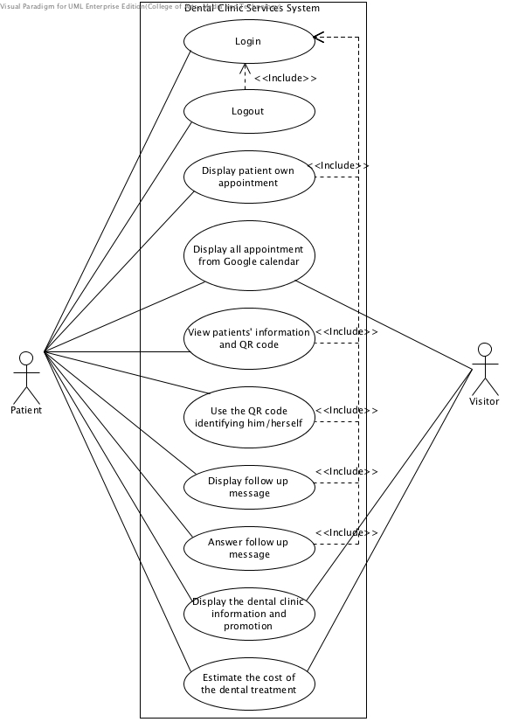

Figure 1: Dental clinic services system patient use case diagram

#### 4.2.2 Dental clinic services system Use Case for Officer

**Officer**

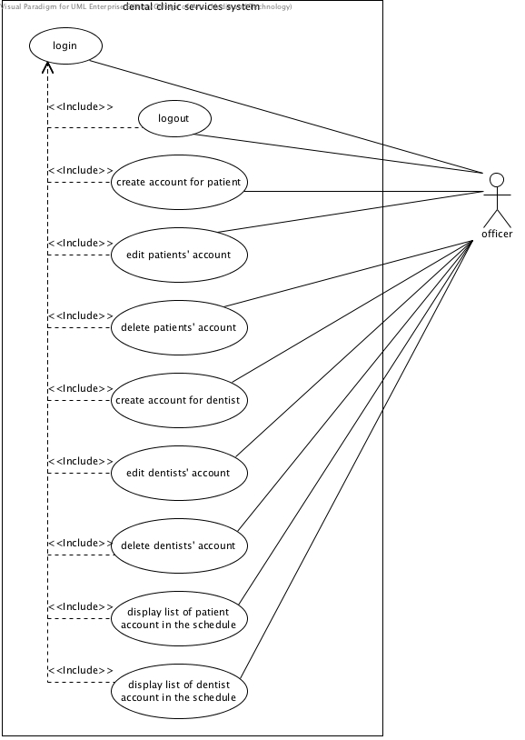

Figure 2: Dental clinic services system officer use case diagram

(Account management)

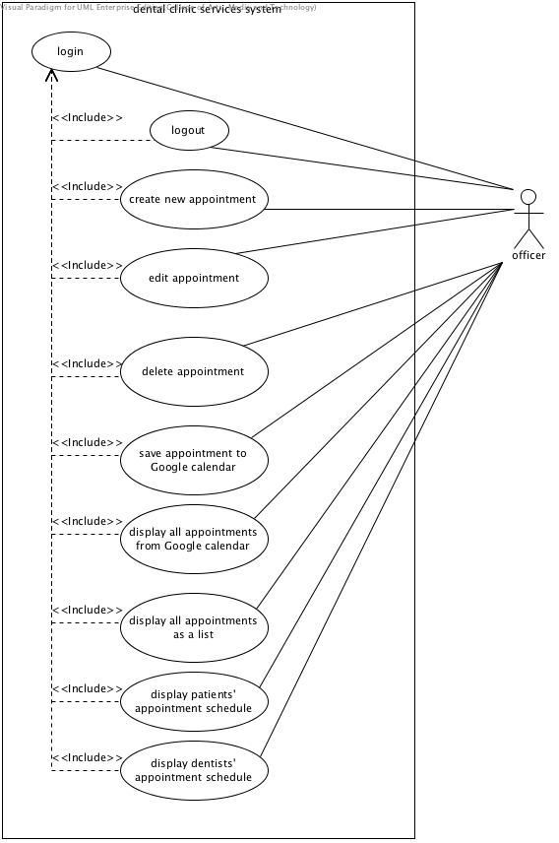

Figure 3: Dental clinic services system officer use case diagram

(Appointment management)

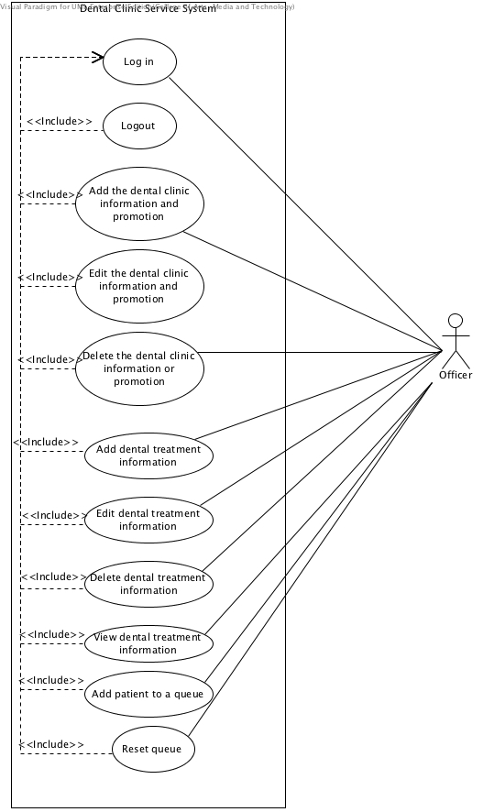

Figure : Dental clinic services system officer use case diagram

#### 4.2.3 Dental clinic services system Use Case for Dentist

**Dentist**

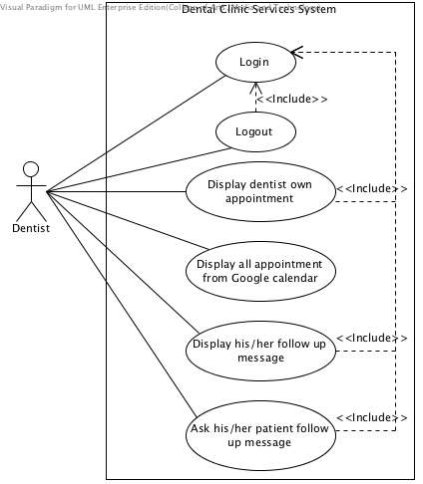

Figure 4: Dental clinic services system dentist use case diagram

### 4.3 Use case description

|  |  |  |  |
| --- | --- | --- | --- |
| Use Case ID: | UC-01 | | |
| Use Case Name: | Display patients’ own appointment in mobile application | | |
| **Created By:** | Worapun Wongkium | **Last Updated By:** | Kanokwan Maneerat |
| **Date Created:** | 17/04/2014 | **Last Revision Date:** | 24/06/2014 |
| **Actors:** | Patient | | |
| **Description:** | Patient can view his/her appointment in appointment page which provide in the mobile application | | |
| **Trigger:** | Patient selects appointment menu | | |
| **Preconditions:** | Patient is already logged into the application by using patientID and password | | |
| **Postconditions:** | Patient can view their appointment in appointment page | | |
| **Normal Flow:** | 1. Patient selects appointment menu 2. System shall connect with the dentalclinic database 3. System shall retrieve patients’ appointment data including appointmentID, patientID, dentistID, appointment date, start time, end time, dental treatment, and description from database 4. System shall provide patients’ appointment data from the database in appointment page in mobile application 5. Patient can view his/her appointment in appointment page | | |
| **Alternative Flows:** | N/A | | |
| **Exceptions:** | System will not connect to the database and deliver information if there is no internet connection. Patient cannot view his/her appointment in mobile application. | | |

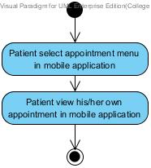

Figure 5: Display patients’ own appointment (in mobile application) [AD-01]

#### 

|  |  |  |  |
| --- | --- | --- | --- |
| Use Case ID: | UC-02 | | |
| Use Case Name: | Display all appointments from Google calendar in mobile application | | |
| **Created By:** | Worapun Wongkium | **Last Updated By:** | Kanokwan Maneerat |
| **Date Created:** | 17/04/2014 | **Last Revision Date:** | 25/06/2014 |
| **Actors:** | Patient | | |
| **Description:** | Patient can view all appointments from Google calendar in calendar page which provide in the mobile application | | |
| **Trigger:** | Patient selects calendar menu | | |
| **Preconditions:** | Patient enters to index page | | |
| **Postconditions:** | Patient can view all appointment from Google calendar in calendar page | | |
| **Normal Flow:** | 1. Patient selects calendar menu 2. System shall provide appointment calendar form Google calendar in calendar page in mobile application 3. Patient can view all appointment form Google calendar in mobile application | | |
| **Alternative Flows:** | N/A | | |
| **Exceptions:** | System will not deliver information if there is no internet connection. Patient cannot view all appointments from Google calendar. | | |

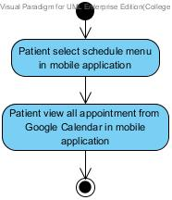

Figure 6: Display all appointment from Google calendar (in mobile application) [AD-02]

|  |  |  |  |
| --- | --- | --- | --- |
| Use Case ID: | UC-03 | | |
| Use Case Name: | Display patients’ own appointment (in website) | | |
| **Created By:** | Worapun Wongkium | **Last Updated By:** | Kanokwan Maneerat |
| **Date Created:** | 17/04/2014 | **Last Revision Date:** | 24/06/2014 |
| **Actors:** | Patient | | |
| **Description:** | Patient can view his/her appointment in the patients’ appointment page which provide in the website | | |
| **Trigger:** | Patient selects patients’ appointment menu | | |
| **Preconditions:** | Patient is already logged into the application by using patientID and password | | |
| **Postconditions:** | Patient can view their appointment schedule | | |
| **Normal Flow:** | 1. Patient selects patients’ schedule menu 2. System shall connect with the dentalclinic database 3. System shall retrieve patients’ appointment data including appointmentID, patientID, dentistID, appointment date, start time, end time, dental treatment, and description from database 4. System shall provide patients’ appointment data from the database in patient appointment page in the website 5. Patient can view his/her appointment in patients’ appointment page | | |
| **Alternative Flows:** | N/A | | |
| **Exceptions:** | System will not connect to the database and deliver information if there is no internet connection. Patient cannot view his/her appointment in website. | | |

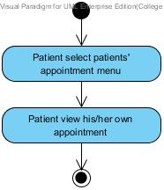

Figure 7: Display patients’ own appointment (in website) [AD-03]

|  |  |  |  |
| --- | --- | --- | --- |
| Use Case ID: | UC-04 | | |
| Use Case Name: | Display dentists’ own appointment (in website) | | |
| **Created By:** | Worapun Wongkium | **Last Updated By:** | Kanokwan Maneerat |
| **Date Created:** | 17/04/2014 | **Last Revision Date:** | 24/06/2014 |
| **Actors:** | Dentist | | |
| **Description:** | Dentist can view his/her own appointment in the dentists’ appointment page which provide in the website | | |
| **Trigger:** | Dentist selects dentists’ appointment menu | | |
| **Preconditions:** | Dentist is already logged into the application by using dentistID and password | | |
| **Postconditions:** | Dentist can view their appointment schedule | | |
| **Normal Flow:** | 1. Dentist selects dentists’ schedule menu 2. System shall connect with the dentalclinic database 3. System shall retrieve dentists’ appointment data including appointmentID, patientID, dentistID, appointment date, start time, end time, dental treatment, and description from database 4. System shall provide dentists’ appointment data from the database in dentist appointment page in the website 5. Dentist can view dentists’ own appointment in dentists’ appointment page | | |
| **Alternative Flows:** | N/A | | |
| **Exceptions:** | System will not connect to the database and deliver information if there is no internet connection. Dentist cannot view his/her appointment in website. | | |
| **Includes:** | Steps 1-5 in the normal flow would be required for all types of display dentists’ own appointment (in website). | | |

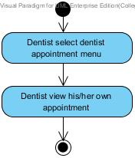

Figure 8: Display dentists’ own appointment (in website) [AD-04]

|  |  |  |  |
| --- | --- | --- | --- |
| Use Case ID: | UC-05 | | |
| Use Case Name: | Display all appointments from Google calendar | | |
| **Created By:** | Worapun Wongkium | **Last Updated By:** | Kanokwan Maneerat |
| **Date Created:** | 17/04/2014 | **Last Revision Date:** | 25/06/2014 |
| **Actors:** | Visitor | | |
| **Description:** | Visitor can view all appointments from Google calendar in the appointment calendar page which provide in the website | | |
| **Trigger:** | Visitor selects appointment calendar menu | | |
| **Preconditions:** | Visitor enters to the website | | |
| **Postconditions:** | Visitor can view all appointment schedule | | |
| **Normal Flow:** | 1. Visitor selects appointment calendar menu 2. System shall provide appointment calendar from Google calendar in appointment calendar page in the website 3. Visitor can view all appointments from Google calendar in appointment calendar page | | |
| **Alternative Flows:** | N/A | | |
| **Exceptions:** | System will not deliver information if there is no internet connection. Visitor cannot view all appointments from Google calendar. | | |

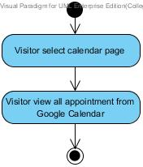

Figure 9: Display all appointment from Google calendar (in website) [AD-05]

|  |  |  |  |
| --- | --- | --- | --- |
| Use Case ID: | UC-06 | | |
| Use Case Name: | Display all appointments as list in website | | |
| **Created By:** | Worapun Wongkium | **Last Updated By:** | Kanokwan Maneerat |
| **Date Created:** | 17/04/2014 | **Last Revision Date:** | 25/06/2014 |
| **Actors:** | Officer | | |
| **Description:** | Officer can view all appointment as a list in website | | |
| **Trigger:** | Officer selects appointment list menu | | |
| **Preconditions:** | Officer is already logged into the application by using officerID and password | | |
| **Postconditions:** | Display all appointments as list in website | | |
| **Normal Flow:** | 1. Officer selects view appointment list menu 2. System shall connect with the dentalclinic database 3. System shall retrieve all appointments’ data including appointmentID, patientID, dentistID, appointment date, start time, end time, dental treatment, and description from database 4. System shall provide all appointments’ data as a list from the database in all appointment page 5. Officer can view all appointments in appointment list page which provide in the website | | |
| **Alternative Flows:** | N/A | | |
| **Exceptions:** | System will not connect to the database and deliver information if there is no internet connection. | | |

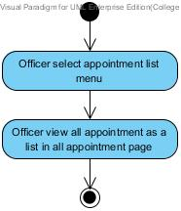

Figure 10: Display all appointments as a list [AD-06]

|  |  |  |  |
| --- | --- | --- | --- |
| Use Case ID: | UC-07 | | |
| Use Case Name: | Display patients’ appointment list for officer | | |
| **Created By:** | Worapun Wongkium | **Last Updated By:** | Kanokwan Maneerat |
| **Date Created:** | 17/04/2014 | **Last Revision Date:** | 25/06/2014 |
| **Actors:** | Officer | | |
| **Description:** | Officer can view patients’ appointment as a list in patient appointment page(for officer) | | |
| **Trigger:** | Officer selects patientID to view his/her appointment in patient list page | | |
| **Preconditions:** | Officer is already logged into the application by using officerID and password | | |
| **Postconditions:** | Display patients’ appointment as a list in patient appointment page(for officer) | | |
| **Normal Flow:** | 1. Officer selects view patient list menu 2. System shall connect with the dentalclinic database 3. System shall retrieve patients’ data including patientID, password, first name, last name, age, gender, address, tel., email, and treatment from the database 4. System shall provide patients’ data as a list in the patient list page 5. Officer selects patientID in the list 6. System shall retrieve all patients’ appointment data including appointmentID, patientID, dentistID, appointment date, start time, end time, dental treatment, and description from database 7. System shall provide patients’ appointment data from the database in patient appointment page (for officer) in the website 8. Officer can view patients’ appointment in patient appointment page(for officer) | | |
| **Alternative Flows:** | N/A | | |
| **Exceptions:** | System will not connect to the database and deliver information if there is no internet connection. | | |

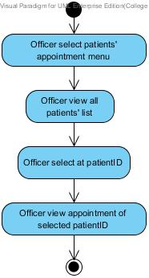

Figure 11: Display patients’ appointments list for officer [AD-07]

|  |  |  |  |
| --- | --- | --- | --- |
| Use Case ID: | UC-08 | | |
| Use Case Name: | Display dentists’ appointment for officer | | |
| **Created By:** | Worapun Wongkium | **Last Updated By:** | Kanokwan Maneerat |
| **Date Created:** | 17/04/2014 | **Last Revision Date:** | 25/06/2014 |
| **Actors:** | Officer | | |
| **Description:** | Officer can view dentists’ appointment as a list in dentist appointment page(for officer) | | |
| **Trigger:** | Officer selects dentistrID(dentist) to view his/her appointment | | |
| **Preconditions:** | Officer is already logged into the application by using officerID and password | | |
| **Postconditions:** | Display dentists’ appointment as a list in dentists’ appointment page (for officer) | | |
| **Normal Flow:** | 1. Officer selects view dentist list interface 2. System shall connect with the dentalclinic database 3. System shall retrieve dentists’ data including dentistID, password, first name, last name, email, and tel. from the database 4. System shall provide dentists’ data as a list in the dentist list page 5. Officer selects dentistID in the list 6. System shall retrieve all dentists’ appointment data including appointmentID, patientID, dentistID, appointment date, start time, end time, dental treatment, and description from database 7. System shall provide dentists’ appointment data from the database in dentist appointment page (for officer) in the website 8. Officer can view dentists’ appointment as a list in dentists’ appointment page**(**for officer**)** | | |
| **Alternative Flows:** | N/A | | |
| **Exceptions:** | System will not connect to the database and deliver information if there is no internet connection. | | |

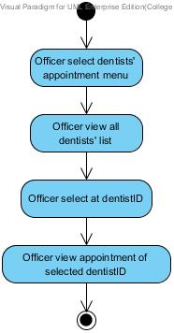

Figure 12: Display dentists’ appointment for officer [AD-08]

|  |  |  |  |
| --- | --- | --- | --- |
| Use Case ID: | UC-09 | | |
| Use Case Name: | Display all appointments from Google calendar | | |
| **Created By:** | Worapun Wongkium | **Last Updated By:** | Kanokwan Maneerat |
| **Date Created:** | 17/04/2014 | **Last Revision Date:** | 25/06/2014 |
| **Actors:** | Registered user | | |
| **Description:** | Registered user can view all appointments from Google calendar in the appointment calendar page which provide in the website | | |
| **Trigger:** | Registered user selects appointment calendar menu | | |
| **Preconditions:** | Registered user enters to the website | | |
| **Postconditions:** | Registered user can view all appointment schedule | | |
| **Normal Flow:** | 1. Registered user selects appointment calendar menu 2. System shall provide appointment calendar from Google calendar in appointment calendar page in the website 3. Registered user can view all appointments from Google calendar in appointment calendar page | | |
| **Alternative Flows:** | N/A | | |
| **Exceptions:** | System will not deliver information if there is no internet connection. Registered users cannot view all appointments from Google calendar. | | |

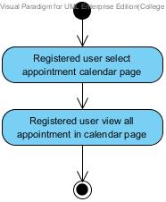

Figure 13: Display all appointment from Google calendar (in website) [AD-09]

|  |  |  |  |
| --- | --- | --- | --- |
| Use Case ID: | UC-10 | | |
| Use Case Name: | Create new appointment | | |
| **Created By:** | Worapun Wongkium | **Last Updated By:** | Kanokwan Maneerat |
| **Date Created:** | 17/04/2014 | **Last Revision Date:** | 25/06/2014 |
| **Actors:** | Officer | | |
| **Description:** | Officer can create a new appointment for patient and dentist | | |
| **Trigger:** | Officer selects make appointment menu | | |
| **Preconditions:** | Officer is already logged into the application by using officerID and password | | |
| **Postconditions:** | Officer can view the new appointment which is already added in all appointment page | | |
| **Normal Flow:** | 1. Officer selects make appointment menu 2. System shall provide create appointment page in the website 3. Officer inputs appointments’ data including patientID, dentistID, appointment date, start time, end time, dental treatment, and description 4. Officer presses submit button 5. System shall connect with the dentalclinic database 6. System shall add appointments’ data including patientID, dentistID, appointment date, start time, end time, dental treatment, and description into the database 7. System shall update appointment table in the database 8. System shall provide all appointments’ data as a list from the database in all appointment page 9. Officer views all appointments as a list in all appointment page | | |
| **Alternative Flows:** | 4a. Officer presses submit button and some field is empty.   1. System shall show error message “Please fill out this field” for any field that requires to be not empty 2. Go back to normal flow 3   4b Officer presses submit button and there are duplicate date, time, and dentist.   1. System shall show error message “Duplicate data” 2. System shall provide create appointment page in the website | | |
| **Exceptions:** | System will not connect to the database and deliver information if there is no internet connection. | | |

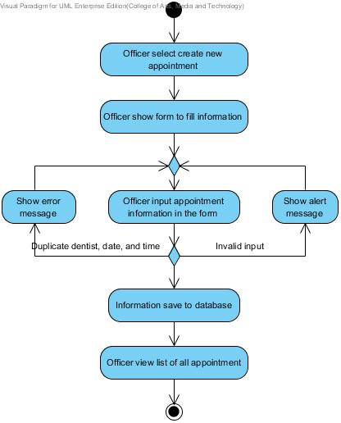

Figure 14: Create new appointment [AD-10]

|  |  |  |  |
| --- | --- | --- | --- |
| Use Case ID: | UC-11 | | |
| Use Case Name: | Edit appointment | | |
| **Created By:** | Kanokwan Maneerat | **Last Updated By:** | Kanokwan Maneerat |
| **Date Created:** | 25/06/2014 | **Last Revision Date:** | 25/06/2014 |
| **Actors:** | Officer | | |
| **Description:** | Officer can edit appointment | | |
| **Trigger:** | Officer selects edit menu in all appointment page | | |
| **Preconditions:** | Officer is already logged into the application by using officerID and password | | |
| **Postconditions:** | Officer can view the appointment which is already edited in all appointment page | | |
| **Normal Flow:** | 1. Officer selects all appointment menu 2. System shall connect with the dentalclinic database 3. System shall retrieve all appointments’ data including appointmentID, patientID, dentistID, appointment date, start time, end time, dental treatment, and description from database 4. System shall provide all appointments’ data as a list from the database in all appointment page 5. Officer selects edit menu at the appointment which want to change in all appointment page 6. System shall provide appointments’ edit page in the website 7. System shall retrieve appointments’ data including including appointmentID, patientID, dentistID, appointment date, start time, end time, dental treatment, and description from database 8. System shall provide appointments’ data in appointment edit page 9. Officer inputs some information that need to change 10. Officer presses submit button 11. System shall edit appointments’ data in appointment table in the database 12. System shall update appointment table in the database 13. System shall provide all appointments’ data as a list from the database in all appointment page 14. Officer views all appointment as a list in all appointment page | | |
| **Alternative Flows:** | 10a. Officer presses submit button and some field is empty   1. System shall show error message “Please fill out this field” for any field that require to not empty 2. Go back to normal flow 9 | | |
| **Exceptions:** | System will not connect to the database and deliver information if there is no internet connection. | | |

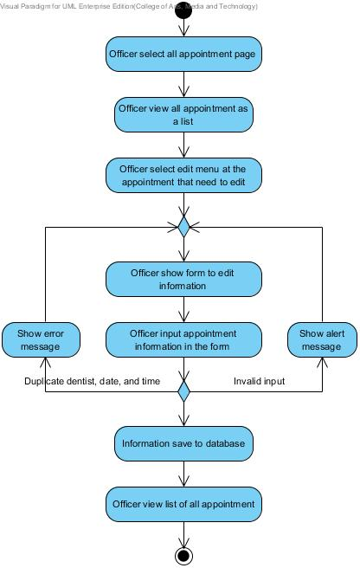

Figure 15: Edit appointment [AD-11]

|  |  |  |  |
| --- | --- | --- | --- |
| Use Case ID: | UC-12 | | |
| Use Case Name: | Delete appointment | | |
| **Created By:** | Kanokwan Maneerat | **Last Updated By:** | Kanokwan Maneerat |
| **Date Created:** | 25/06/2014 | **Last Revision Date:** | 25/06/2014 |
| **Actors:** | Officer | | |
| **Description:** | Officer can delete appointment | | |
| **Trigger:** | Officer selects delete menu in all appointment page | | |
| **Preconditions:** | Officer is already logged into the application by using officerID and password | | |
| **Postconditions:** | Officer can view the appointment which is already deleted in all appointment page | | |
| **Normal Flow:** | 1. Officer selects all appointment menu 2. System shall connect with the dentalclinic database 3. System shall retrieve all appointments’ data including appointmentID, patientID, dentistID, appointment date, start time, end time, dental treatment, and description from database 4. System shall provide all appointments’ data as a list from the database in all appointment page 5. Officer selects delete menu that need to delete 6. System shall delete appointments’ data in appointment table in the database 7. System shall update appointment table in the database 8. Officer can view all appointments as a list in all appointment page | | |
| **Alternative Flows:** | N/A | | |
| **Exceptions:** | System will not connect to the database and deliver information if there is no internet connection. | | |

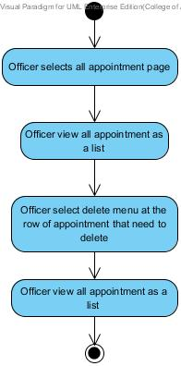

Figure 16: Delete appointments [AD-12]

|  |  |  |  |
| --- | --- | --- | --- |
| Use Case ID: | UC-13 | | |
| Use Case Name: | Save the appointment to Google calendar | | |
| **Created By:** | Worapun Wongkium | **Last Updated By:** | Kanokwan Maneerat |
| **Date Created:** | 17/04/2014 | **Last Revision Date:** | 25/06/2014 |
| **Actors:** | Officer | | |
| **Description:** | Officer can save appointment to the Google calendar | | |
| **Trigger:** | Officer selects view all appointments page | | |
| **Preconditions:** | Officer is already logged into the application by using officerID and password | | |
| **Postconditions:** | New appointment added to Google calendar and can view in Google calendar | | |
| **Normal Flow:** | 1. Officer selects view all appointments page 2. System shall connect with the dentalclinic database 3. System shall retrieve all appointments’ data including appointmentID, patientID, dentistID, appointment date, start time, end time, dental treatment, and description from database 4. System shall provide all appointments’ data as a list from the database in all appointment page 5. Officer selects save appointment to Google calendar menu 6. System shall redirect to Google calendar page 7. System shall provide appointments’ data from the database in Google calendar form in Google website 8. Officer presses save button in Google calendar page 9. System shall save appointments’ data into the Google calendar 10. Officer can view appointments’ data in Google calendar which is provide in appointment calendar page in DCSS website | | |
| **Alternative Flows:** | 5a.Officer presses save button or cancel saving appointments’ data   1. System will not save Appointments’ data to Google Calendar | | |
| **Exceptions:** | System will not connect to the database, Google website and deliver information if there is no internet connection. | | |

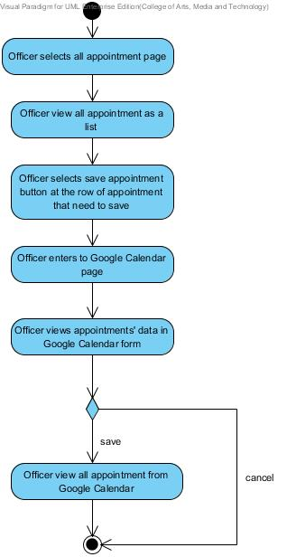

Figure 17: Save appointment to Google calendar [AD-13]

|  |  |  |  |
| --- | --- | --- | --- |
| Use Case ID: | UC-14 | | |
| Use Case Name: | Login (in mobile application) | | |
| **Created By:** | Worapun Wongkium | **Last Updated By:** | Kanokwan Maneerat |
| **Date Created:** | 17/04/2014 | **Last Revision Date:** | 23/06/2014 |
| **Actors:** | Patient | | |
| **Description:** | Patient can login for identifying him/herself to mobile application. | | |
| **Trigger:** | Patient selects login menu in dental clinic services application | | |
| **Preconditions:** | Patient enters to the dental clinic services application. | | |
| **Postconditions:** | Patient enters to the application | | |
| **Normal Flow:** | 1. Patient selects at login menu 2. System shall provide patient login page in mobile application 3. Patient inputs patientID and password in login page 4. Patient presses login button 5. System shall connect with the dentalclinic database 6. System shall validate patientID and password from input form matching with the data in patient table in the database 7. System shall store session after login success 8. System shall redirect to index page in mobile application 9. Patient enters to index page in mobile application | | |
| **Alternative Flows:** | 4a. Patient press login button and some field is empty   1. System shall display error message if there are empty fields “Please input patientID and password” in mobile application 2. System shall redirect to patient login page if login fail   5a. patientID or password are not match with the data in patient table in the database   1. System shall display error message if login fail “You’re login fail” in mobile application 2. System shall redirect to patient login page if login fail | | |
| **Exceptions:** | System will not connect to the database and deliver information if there is no internet connection. Patient cannot login to the mobile application. | | |

|  |  |  |  |
| --- | --- | --- | --- |
| Use Case ID: | UC-15 | | |
| Use Case Name: | Login (in website) | | |
| **Created By:** | Worapun Wongkium | **Last Updated By:** | Kanokwan Maneerat |
| **Date Created:** | 17/04/2014 | **Last Revision Date:** | 23/06/2014 |
| **Actors:** | Patient, Officer, Dentist | | |
| **Description:** | Registered user can login for identifying him/herself to website | | |
| **Trigger:** | Registered user selects login menu in dental clinic website | | |
| **Preconditions:** | Registered user enters to the dental clinic website | | |
| **Postconditions:** | Registered user can use the services that requires log in. | | |
| **Normal Flow:** | 1. Registered user selects at login menu 2. System shall connect with the dentalclinic database 3. System shall provide patient login page in the website 4. Registered user inputs ID (patientID,dentistID,officerID) and password (patient,dentist,officer) 5. Registered user presses login button 6. System shall validate patientID and password from input form matching with the data in patient table in the database 7. System shall redirect to patient login page if login fail 8. System shall validate dentistID and password from input form matching with the data in dentist table in the database 9. System shall redirect to dentist login page if login fail 10. System shall validate officerID and password from input form matching with the data in officer table in the database 11. System shall redirect to officer login page if login fail 12. System shall store session after login success 13. System shall redirect to index page in the website 14. Registered user enters to index page in the website | | |
| **Alternative Flows:** | 6a. patientID or password does not match the data in patient table in the database   1. System shall display alert message “Invalid patientID or password” 2. Go back to normal flow 4   7a. dentistID or password does not match the data in dentist table in the database   1. System shall display alert message “Invalid dentistID or password 2. Go back to normal flow 4   8a. officerID or password does not match the data in officer table in the database   1. System shall display alert message “Invalid officerID or password” 2. Go back to normal flow 4 | | |
| **Exceptions:** | System will not connect to the database and deliver information if there is no internet connection. Registered user cannot login to the website. | | |

|  |  |  |  |
| --- | --- | --- | --- |
| Use Case ID: | UC-16 | | |
| Use Case Name: | Logout (in mobile application) | | |
| **Created By:** | Worapun Wongkium | **Last Updated By:** | Kanokwan Maneerat |
| **Date Created:** | 17/04/2014 | **Last Revision Date:** | 23/06/2014 |
| **Actors:** | Patient | | |
| **Description:** | Patient can logout from the system | | |
| **Trigger:** | Patient selects logout button | | |
| **Preconditions:** | Patient is already logged into the system | | |
| **Postconditions:** | Patient logged out of the system and redirect to index page | | |
| **Normal Flow:** | 1. Patient selects logout menu 2. System shall connect with the dentalclinic database 3. System shall destroy session 4. System shall redirect to index page in mobile application 5. Patient enters to index page in mobile application | | |
| **Alternative Flows:** | N/A | | |
| **Exceptions:** | System will not connect to the database and deliver information if there is no internet connection. Patient cannot logout to the mobile application. | | |

|  |  |  |  |
| --- | --- | --- | --- |
| Use Case ID: | UC-17 | | |
| Use Case Name: | Logout (in website) | | |
| **Created By:** | Worapun Wongkium | **Last Updated By:** | Kanokwan Maneerat |
| **Date Created:** | 17/04/2014 | **Last Revision Date:** | 23/06/2014 |
| **Actors:** | Patient, Officer, Dentist | | |
| **Description:** | Registered User can logout from the system | | |
| **Trigger:** | Registered User selects logout button | | |
| **Preconditions:** | Registered User is already logged into the system | | |
| **Postconditions:** | Registered User is logged out of the system and redirects to main home page | | |
| **Normal Flow:** | 1. Registered User selects logout menu 2. System shall connect with the dentalclinic database 3. System shall destroy session 4. System shall redirect to index page in the website 5. Registered user enters to index page in the website | | |
| **Alternative Flows:** | N/A | | |
| **Exceptions:** | System will not connect to the database and deliver information if there is no internet connection. Registered user must login to the website first | | |

|  |  |  |  |
| --- | --- | --- | --- |
| Use Case ID: | UC-18 | | |
| Use Case Name: | Create new account for patient | | |
| **Created By:** | Worapun Wongkium | **Last Updated By:** | Kanokwan Maneerat |
| **Date Created:** | 17/04/2014 | **Last Revision Date:** | 25/06/2014 |
| **Actors:** | Officer | | |
| **Description:** | Officer can create an account for new patient to use the services from dental clinic | | |
| **Trigger:** | Officer selects create new patient menu | | |
| **Preconditions:** | Officer is already logged into the application by using officerID and password | | |
| **Postconditions:** | New patients’ account is added to the system and can view patient account as a list in patient list page | | |
| **Normal Flow:** | 1. Officer selects new patient menu 2. System shall provide create patient account page in the website 3. System shall connect with the dentalclinic database 4. Officer inputs patients’ data including patientID, password, first name, last name, age, gender, address, tel., email, and treatment in create form 5. Officer presses submit button 6. System shall add patients’ data including patientID, password, first name, last name, age, gender, address, tel., email, and treatment into the database 7. System shall update patient table in the database 8. System shall retrieve patients’ data including patientID, password, first name, last name, age, gender, address, tel., email, and treatment from the database 9. System shall provide patients’ data as a list in the patient list page 10. Officer views a new patients’ account in patient list page | | |
| **Alternative Flows:** | 5a. Officer presses submit button and some field is empty   1. System shall show error message “Please fill out this field” for any field that requires to be not empty 2. Go back to normal flow 4   5b. Officer presses submit button and duplicate patientID  1. System shall show error message “Duplicate data”  2. System shall provide create patient account page in the website | | |
| **Exceptions:** | System will not connect to the database and deliver information if there is no internet connection. | | |

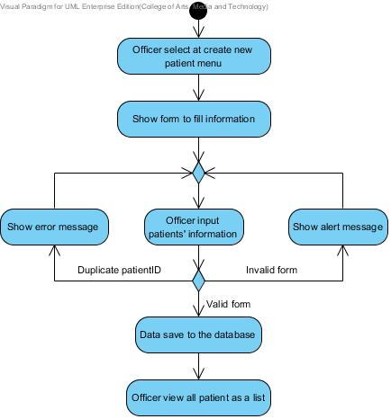

Figure 18: Create new account for patient [AD-14]

|  |  |  |  |
| --- | --- | --- | --- |
| Use Case ID: | UC-19 | | |
| Use Case Name: | Edit patients’ information | | |
| **Created By:** | Kanokwan Maneerat | **Last Updated By:** | Kanokwan Maneerat |
| **Date Created:** | 25/06/2014 | **Last Revision Date:** | 25/06/2014 |
| **Actors:** | Officer | | |
| **Description:** | Officer can edit patients’ information | | |
| **Trigger:** | Officer selects edit menu in patient list page | | |
| **Preconditions:** | Officer is already logged into the application by using officerID and password | | |
| **Postconditions:** | New information of patient is edited and can view as a list in patient list page | | |
| **Normal Flow:** | 1. Officer selects patient list page 2. System shall connect with the dentalclinic database 3. System shall retrieve patients’ data including patientID, password, first name, last name, age, gender, address, tel., email, and treatment from the database 4. System shall provide patients’ data as a list in the patient list page 5. Officer selects edit menu 6. System shall provide patients’ edit page in the website 7. Officer inputs some patients’ information that need to change 8. Officer presses submit button 9. System shall edit patients’ information in patient table in the database 10. System shall update patient table in the database 11. System shall provide patients’ data as a list in the patient list page 12. Officer views all patient accounts as a list in patient list page | | |
| **Alternative Flows:** | 8a. Officer press submit button and some field is empty   1. System shall show error message “Please fill out this field” for any field that requires to be not empty 2. Go back to normal flow 7 | | |
| **Exceptions:** | System will not connect to the database and deliver information if there is no internet connection. | | |

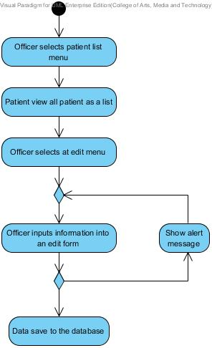

Figure 19: Edit patients’ information [AD-15]

|  |  |  |  |
| --- | --- | --- | --- |
| Use Case ID: | UC-20 | | |
| Use Case Name: | Delete patients’ account | | |
| **Created By:** | Kanokwan Maneerat | **Last Updated By:** | Kanokwan Maneerat |
| **Date Created:** | 25/06/2014 | **Last Revision Date:** | 25/06/2014 |
| **Actors:** | Officer | | |
| **Description:** | Officer can delete patients’ account | | |
| **Trigger:** | Officer selects delete menu in patient list page | | |
| **Preconditions:** | Officer is already logged into the application by using officerID and password | | |
| **Postconditions:** | Patients’ account is deleted from the system | | |
| **Normal Flow:** | 1. Officer selects patient list page 2. System shall connect with the dentalclinic database 3. System shall retrieve patients’ data including patientID, password, first name, last name, age, gender, address, tel., email, and treatment from the database 4. System shall provide patients’ data as a list in the patient list page 5. Officer selects delete menu 6. System shall delete patients’ account in patient table in the database 7. System shall update patient table in the database 8. Officer views all patient accounts as a list in patient list page | | |
| **Alternative Flows:** | N/A | | |
| **Exceptions:** | System will not connect to the database and deliver information if there is no internet connection. | | |

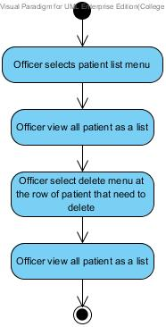

Figure 20: Delete patients’ account [AD-16]

|  |  |  |  |
| --- | --- | --- | --- |
| Use Case ID: | UC-21 | | |
| Use Case Name: | Create new account for dentist | | |
| **Created By:** | Worapun Wongkium | **Last Updated By:** | Kanokwan Maneerat |
| **Date Created:** | 17/04/2014 | **Last Revision Date:** | 25/06/2014 |
| **Actors:** | Officer | | |
| **Description:** | Officer can create an account for new dentist to use the services from dental clinic | | |
| **Trigger:** | Officer selects create new dentist menu | | |
| **Preconditions:** | Officer is already logged into the application by using officerID and password | | |
| **Postconditions:** | New dentist s’ account is added to the system and can view as dentist account as a list in dentist list page | | |
| **Normal Flow:** | 1. Officer selects create new dentist menu 2. System shall provide create dentist account page in the website 3. System shall connect with the dentalclinic database 4. Officer shall input dentists’ data including dentistID, password, first name, last name, address, email, and tel. in creating form 5. Officer press submit button 6. System shall add dentists’ data including dentistID, password, first name, last name, address, email, and tel. into the database 7. System shall update dentist table in the database 8. System shall retrieve dentists’ data including dentistID, password, first name, last name, email, and tel. from the database 9. System shall provide dentists’ data as a list in the dentist list page 10. Officer views dentist account in dentist list page | | |
| **Alternative Flows:** | 5a.Officer press submit button and some field is empty   1. System shall show error message “Please fill out this field” for any field that requires to be not empty 2. Go back to normal flow 4   5a.Officer press submit button and duplicate dentistID   1. System shall show error message “Duplicate data” 2. System shall provide create dentist account page in the website | | |
| **Exceptions:** | System will not connect to the database and deliver information if there is no internet connection. | | |

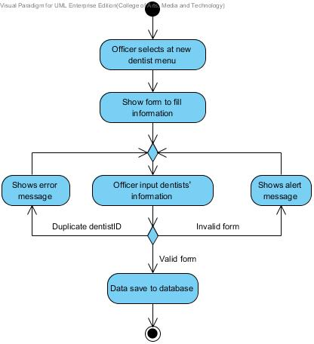

Figure 21: Create new account for dentist [AD-17]

|  |  |  |  |
| --- | --- | --- | --- |
| Use Case ID: | UC-22 | | |
| Use Case Name: | Edit dentists’ information | | |
| **Created By:** | Kanokwan Maneerat | **Last Updated By:** | Kanokwan Maneerat |
| **Date Created:** | 25/06/2014 | **Last Revision Date:** | 25/06/2014 |
| **Actors:** | Officer | | |
| **Description:** | Officer can edit dentist s’ information | | |
| **Trigger:** | Officer selects edit menu in dentist list page | | |
| **Preconditions:** | Officer is already logged into the application by using officerID and password | | |
| **Postconditions:** | New information of dentist is edited and can view dentist account as a list | | |
| **Normal Flow:** | 1. Officer selects dentist list page 2. System shall connect with the dentalclinic database 3. System shall retrieve dentists’ data including dentistID, password, first name, last name, email, and tel. from the database 4. System shall provide dentists’ data as a list in the dentist list page 5. Officer selects edit menu 6. System shall provide dentists’ edit page in the website 7. Officer inputs some dentists’ information that need to change in edit form 8. Officer presses submit button 9. System shall edit dentists’ information in dentist table in the database 10. System shall update dentist table in the database 11. System shall provide dentists’ data as a list in the dentist list page 12. Officer views dentist account in dentist list page | | |
| **Alternative Flows:** | 8a. Officer presses submit button and some field is empty   1. System shall show error message “Please fill out this field” for any field that requires to be not empty 2. Go back to normal flow 7 | | |
| **Exceptions:** | System will not connect to the database and deliver information if there is no internet connection. | | |

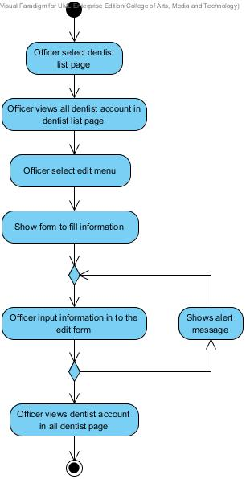

Figure 22: Edit dentists’ information [AD-18]

|  |  |  |  |
| --- | --- | --- | --- |
| Use Case ID: | UC-23 | | |
| Use Case Name: | Delete dentist s’ account | | |
| **Created By:** | Kanokwan Maneerat | **Last Updated By:** | Kanokwan Maneerat |
| **Date Created:** | 25/06/2014 | **Last Revision Date:** | 25/06/2014 |
| **Actors:** | Officer | | |
| **Description:** | Officer can delete dentists’ account | | |
| **Trigger:** | Officer selects delete menu in dentist list page | | |
| **Preconditions:** | Officer is already logged into the application by using officerID and password | | |
| **Postconditions:** | Dentists’ account is delete from the system | | |
| **Normal Flow:** | 1. Officer selects dentist list page 2. System shall connect with the dentalclinic database 3. System shall retrieve dentists’ data including dentistID, password, first name, last name, email, and tel. from the database 4. System shall provide dentists’ data as a list in the dentist list page 5. Officer selects delete menu 6. System shall delete dentists’ account in dentist table in the database 7. System shall update dentist table in the database 8. System shall provide dentists’ data as a list in the dentist list page 9. Officer views dentist account in dentist list page | | |
| **Alternative Flows:** | N/A | | |
| **Exceptions:** | System will not connect to the database and deliver information if there is no internet connection. | | |

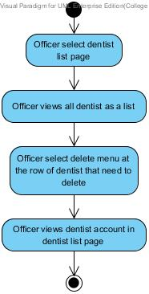

Figure 23: Delete dentists’ account [AD-19]

|  |  |  |  |
| --- | --- | --- | --- |
| Use Case ID: | UC-24 | | |
| Use Case Name: | Display patients’ list | | |
| **Created By:** | Worapun Wongkium | **Last Updated By:** | Kanokwan Maneerat |
| **Date Created:** | 17/04/2014 | **Last Revision Date:** | 25/06/2014 |
| **Actors:** | Officer | | |
| **Description:** | Officer can view list of patient from website | | |
| **Trigger:** | Officer selects patient list page | | |
| **Preconditions:** | Officer is already logged into the application by using officerID and password | | |
| **Postconditions:** | The list of patient is shown | | |
| **Normal Flow:** | 1. Officer selects patient list menu 2. System shall connect with the dentalclinic database 3. System shall retrieve patients’ data including patientID, password, first name, last name, age, gender, address, tel., email, and treatment from the database 4. System shall provide patients’ data as a list in the patient list page 5. Officer views all patients’ accounts in patient list page | | |
| **Alternative Flows:** | N/A | | |
| **Exceptions:** | System will not connect to the database and deliver information if there is no internet connection. | | |

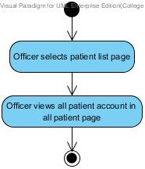

Figure 24: Display dentists’ list [AD-20]

|  |  |  |  |
| --- | --- | --- | --- |
| Use Case ID: | UC-25 | | |
| Use Case Name: | Display dentists’ list | | |
| **Created By:** | Worapun Wongkium | **Last Updated By:** | Kanokwan Maneerat |
| **Date Created:** | 17/04/2014 | **Last Revision Date:** | 25/06/2014 |
| **Actors:** | Officer | | |
| **Description:** | Officer can view list of patient from website | | |
| **Trigger:** | Officer selects dentist list page | | |
| **Preconditions:** | Officer is already logged into the application by using officerID and password | | |
| **Postconditions:** | The list of dentist is shown | | |
| **Normal Flow:** | 1. Officer selects dentist list page 2. System shall connect with the dentalclinic database 3. System shall retrieve dentists’ data including dentistID, password, first name, last name, email, and tel. from the database 4. System shall provide dentists’ data as a list in the dentist list page 5. Officer views all dentists’ accounts in dentist list page | | |
| **Alternative Flows:** | N/A | | |
| **Exceptions:** | System will not connect to the database and deliver information if there is no internet connection. | | |

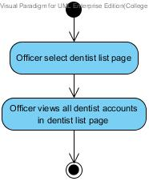

Figure 25: Display dentists’ list [AD-21]

|  |  |  |  |
| --- | --- | --- | --- |
| Use Case ID: | UC-26 | | |
| Use Case Name: | View patients’ information and QR code(mobile) | | |
| **Created By:** | Worapun Wongkium | **Last Updated By:** | Kanokwan Maneeerat |
| **Date Created:** | 15/09/2014 | **Last Revision Date:** | 19/10/2014 |
| **Actors:** | Patient | | |
| **Description:** | Patient can view their own details and QR code. QR code you identify the patient at the clinic. | | |
| **Trigger:** | Patient select the patients’ details menu | | |
| **Preconditions:** | Patient is already logged into the application by using patientID and password | | |
| **Postconditions:** | Patient can view QR code and use QR code to identify his/her self at the clinic | | |
| **Normal Flow:** | 1. Patient selects “Details” menu in the mobile application 2. System shall connect with the dentalclinic database 3. System shall retrieve patients’ data including patientID, password, first name, last name, age, gender, address, tel., email, and treatment from patient table in the dentalclinic database 4. System shall generate the patient’s QR code in mobile application 5. System shall provide the patients’ information including QR code in view information page in mobile application 6. Patient can view QR code and use QR code to identify his/her self at the clinic | | |
| **Alternative Flows:** | N/A | | |
| **Exceptions:** | The patient will not have the QR code if he/she does not register to the dental clinic. | | |

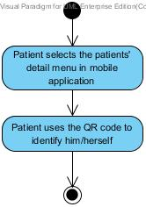

Figure 5: Display patients’ information and QR code in website [AD-22]

|  |  |  |  |
| --- | --- | --- | --- |
| Use Case ID: | UC-27 | | |
| Use Case Name: | View patients’ information and QR code(in website) | | |
| **Created By:** | Kanokwan Maneeerat | **Last Updated By:** | Kanokwan Maneeerat |
| **Date Created:** | 19/10/2014 | **Last Revision Date:** | 19/10/2014 |
| **Actors:** | Patient | | |
| **Description:** | Patient can view their own details and QR code. QR code you identify the patient at the clinic. | | |
| **Trigger:** | Patient select the patients’ details menu | | |
| **Preconditions:** | Patient is already logged into the website by using patientID and password | | |
| **Postconditions:** | Patient can view QR code | | |
| **Normal Flow:** | 1. Patient selects “Your Details” menu in the mobile application 2. System shall connect with the dentalclinic database 3. System shall retrieve patients’ data including patientID, password, first name, last name, age, gender, address, tel., email, and treatment from patient table in the dentalclinic database 4. System shall generate the patient’s QR code in the website 5. System shall provide the patients’ information including QR code in view information page in in the website | | |
| **Alternative Flows:** | N/A | | |
| **Exceptions:** | The patient will not has the QR code if he/she does not register to the dental clinic. | | |

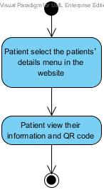

Figure 6: Display patients’ information and QR code in mobile application [AD-23]

|  |  |  |  |
| --- | --- | --- | --- |
| Use Case ID: | UC-28 | | |
| Use Case Name: | Add patient to a queue | | |
| **Created By:** | Kanokwan Maneerat | **Last Updated By:** | Kanokwan Maneerat |
| **Date Created:** | 19/10/2014 | **Last Revision Date:** | 19/10/2014 |
| **Actors:** | Officer | | |
| **Description:** | Officer can input patientID from QR code reader to add a patient into a queue | | |
| **Trigger:** | Officer select the add queue menu | | |
| **Preconditions:** | Officer is already logged into the website by using officerID and password | | |
| **Postconditions:** | Patient added to a queue | | |
| **Normal Flow:** | 1. Officer selects the add queue menu 2. System shall connect with the dentalclinic database 3. System shall provide page for checking an appointment date and time 4. System shall check time of input patientID and return the time of appointment 5. System shall provide the add queue page to add patient to a queue 6. System shall add patient into a queue | | |
| **Alternative Flows:** | 4a. System shall check time of input patientID and return “Not today” for not match date   1. System shall provide check time result page   4b. System shall check time of input patientID and return “No appointment” for the patientID that is not appointed   1. System shall provide check time result page   4c. System shall check time of input patientID and return “You’re missed” for the patientID that is late   1. System shall provide check time result page | | |
| **Exceptions:** | System will not connect to the database and deliver information if there is no internet connection. | | |

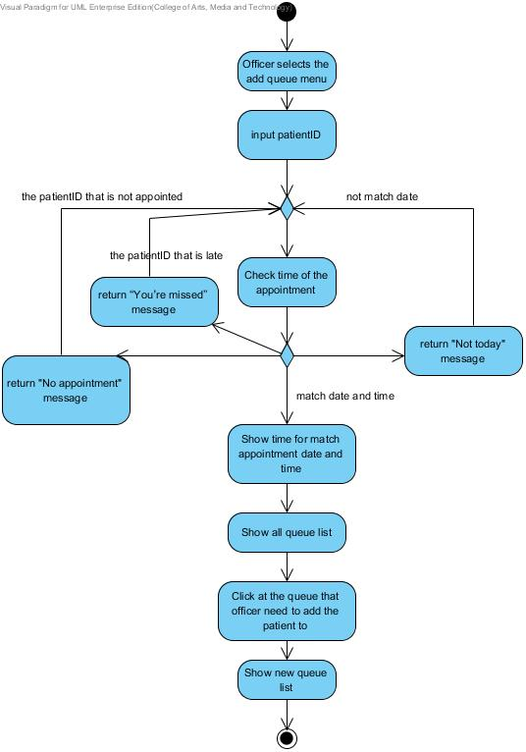

Figure 7: Add patient to a queue [AD-24]

|  |  |  |  |
| --- | --- | --- | --- |
| Use Case ID: | UC-29 | | |
| Use Case Name: | Reset queue | | |
| **Created By:** | Kanokwan Maneeerat | **Last Updated By:** | Kanokwan Maneeerat |
| **Date Created:** | 19/10/2014 | **Last Revision Date:** | 19/10/2014 |
| **Actors:** | Officer | | |
| **Description:** | Officer can reset a queue every end of the day to clear the queue for the next day | | |
| **Trigger:** | Officer select the reset queue button in the add queue page | | |
| **Preconditions:** | Officer is already logged into the website by using officerID and password | | |
| **Postconditions:** | A queue is empty | | |
| **Normal Flow:** | 1. Officer select the reset queue button in the add queue page 2. System shall provide the page for reset a queue 3. System shall connect with the dentalclinic database 4. Officer select the confirm button 5. System shall set all queue to be empty | | |
| **Alternative Flows:** | 4a. Officer not select confirm button   1. System shall provide the add queue page to add patient to a queue | | |
| **Exceptions:** | System will not connect to the database and deliver information if there is no internet connection. | | |

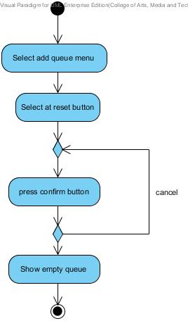

Figure 8: Reset queue [AD-25]

|  |  |  |  |
| --- | --- | --- | --- |
| Use Case ID: | UC-30 | | |
| **Use Case Name:** | View identification result of patient | | |
| **Created By:** | Kanokwan Maneerat | **Last Updated By:** | Worapun Wongkium |
| **Date Created:** | 19/10/2014 | **Last Revision Date:** | 19/10/2014 |
| **Actors:** | Patient, Officer | | |
| **Description:** | Officer can view patients’ identification from QuickMark after patient use QuickMark to read QR code. | | |
| **Trigger:** | Patient selects to view QR code function, Officer open QuickMark and webcam to be ready to use. | | |
| **Preconditions:** | Patient and Officer is already logged in to the website by using their ID and password | | |
| **Postconditions:** | Officer can view patients’ identification result | | |
| **Normal Flow:** | 1. Patient select at your QR menu 2. System shall connect with the dentalclinic database 3. System shall retrieve the patient’s appointment data from appointment table that including patientID, dentistID, appointment date, start time, endtime, treatment and description from dentalclinic database 4. System shall provide the patient’s appointment data from appointment table that including patientID, dentistID, appointment date, start time, endtime, treatment and description from dentalclinic database in the patient appointment page 5. Officer click at the result in QuickMark 6. System shall redirect to the own patient personal information page | | |
| **Alternative Flows:** | N/A | | |
| **Exceptions:** | System will not connect to the database and deliver information if there is no internet connection. | | |

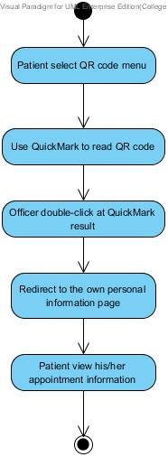

Figure 8: Officer can view patients’ identification result [AD-00]

|  |  |  |  |
| --- | --- | --- | --- |
| Use Case ID: | UC-31 | | |
| Use Case Name: | Display his/her follow up message | | |
| **Created By:** | Worapun Wongkium | **Last Updated By:** | Worapun Wongkium |
| **Date Created:** | 15/09/2014 | **Last Revision Date:** | 14/10/2014 |
| **Actors:** | Dentist | | |
| **Description:** | Dentist can view his/her patient follow up message as a list | | |
| **Trigger:** | Dentist select dent follow up page | | |
| **Preconditions:** | Dentist is already logged into the website by using dentistID and password | | |
| **Postconditions:** | Dentist can view the patient’s follow up message as a list in dent follow up page | | |
| **Normal Flow:** | 1. Dentist select dent follow up page in the website 2. System shall provide the dent follow up page in the website 3. System shall connect with the dentalclinic database 4. System shall retrieve the follow up’s data including patientID, dentistID, question, answer, question time, and answer time from followup table the dentalclinic database 5. System shall provide the follow up’s data including question, answer, question time, and answer time as a list from followup table the dentalclinic database into the dent follow up page in website 6. Dentist can view all his/her patient’s follow up message as alist in dent follow up page | | |
| **Alternative Flows:** | N/A | | |
| **Exceptions:** | System will not connect to the database and deliver information if there is no internet connection. | | |

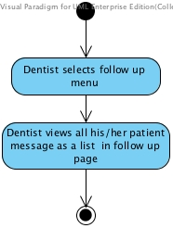

Figure 9: Display his/her follow up message [AD-26]

|  |  |  |  |
| --- | --- | --- | --- |
| Use Case ID: | UC-32 | | |
| Use Case Name: | Post the question for following up with his/her patient | | |
| **Created By:** | Worapun Wongkium | **Last Updated By:** | Kanokwan Maneerat |
| **Date Created:** | 15/09/2014 | **Last Revision Date:** | 19/10/2014 |
| **Actors:** | Dentist | | |
| **Description:** | Dentist can post question to follow up his/her patient | | |
| **Trigger:** | Dentist select patientID in the list for asking | | |
| **Preconditions:** | Dentist is already logged into the website by using dentistID and password | | |
| **Postconditions:** | Dentist is already leave the question for following up his/her patient in dent follow up page | | |
| **Normal Flow:** | 1. Dentist select dent follow up page 2. System shall provide the dent follow up page in the website 3. System shall connect with the dentalclinic database 4. System shall retrieve the patient’s message data including the question and answer from the database 5. System shall provide the patient’s message data as a list in the dent follow up page in the website 6. Dentist select patientID to ask some question with his/her patient for following up 7. System shall provide the follow up form in the dent follow up page in the website 8. Dentist input the question in the form and press submit button 9. System shall add the dentist’s message data including question and answer 10. System shall update follow up table in the dentalclinic database 11. Dentist enter into the dent follow up page 12. System shall retrieve the follow up’s data including patientID, dentistID, question, answer, question time, and answer time from followup table the dentalclinic database 13. System shall provide the follow up’s data including question, answer, question time, and answer time as a list from followup table the dentalclinic database into the dent follow up page in website 14. Dentist can view his/her status that is the question is posted or not 15. Dentist can view his/her patient answer’s status that is patient already answer or notinto the dentalclinic database | | |
| **Alternative Flows:** | 8a. Dentist presses submit button and some field is empty.   1. System shall show error message “Please fill out this field” for any field that requires being not empty 2. Go back to normal flow 8   14a. Dentist can view his/her status that is the answer is posted or not   1. System shall return true if the question is already save 2. System shall return false if the question is not saved yet   15a. Dentist can view his/her dentists question’s status that is dentist is already post or not   1. System shall return true if the answer is already save 2. System shall return false if the answer is not saved yet | | |
| **Exceptions:** | System will not connect to the database and deliver information if there is no internet connection. | | |

* 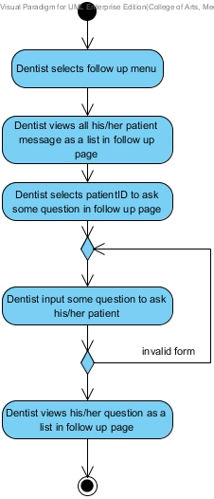

Figure 10: Post the question for following up with his/her patient [AD-27]

|  |  |  |  |
| --- | --- | --- | --- |
| Use Case ID: | UC-33 | | |
| Use Case Name: | Display follow up message | | |
| **Created By:** | Worapun Wongkium | **Last Updated By:** | Worapun Wongkium |
| **Date Created:** | 15/09/2014 | **Last Revision Date:** | 14/10/2014 |
| **Actors:** | Patient | | |
| **Description:** | Patient can view follow up massage that his/her dentist asked in thewebsiteas a list | | |
| **Trigger:** | Patient selects patient follow up page | | |
| **Preconditions:** | Patient is already logged into the website by using patientID and password | | |
| **Postconditions:** | Patient can view the dentist’s follow up message as a list patient follow up page | | |
| **Normal Flow:** | 1. Patient select the patient follow up page in the website 2. System shall connect with the dentalclinic database 3. System shall provide the follow up page in the website 4. System shall retrieve the follow up’s data including patientID, dentistID, question, answer, question time, and answer time from followup table the dentalclinic database 5. System shall provide the follow up’s data including question, answer, question time, and answer time as a list from followup table the dentalclinic database into the follow up page in website 6. Patient can view all his/her dentist’s follow up message as a list in patient follow up page | | |
| **Alternative Flows:** | N/A | | |
| **Exceptions:** | System will not connect to the database and deliver information if there is no internet connection. | | |

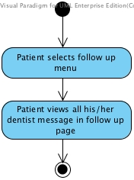

Figure 11: Display follow up message [AD-28]

|  |  |  |  |
| --- | --- | --- | --- |
| Use Case ID: | UC-34 | | |
| Use Case Name: | Answer follow up question | | |
| **Created By:** | Worapun Wongkium | **Created By:** | Kanokwan Maneerat |
| **Date Created:** | 15/09/2014 | **Date Created:** | 19/10/2014 |
| **Actors:** | Patient | | |
| **Description:** | Patient can answer follow up massage that his/her dentist asked in thewebsite | | |
| **Trigger:** | Patient select the question from his/her dentist for answer | | |
| **Preconditions:** | Patient is already logged into the website by using patientID and password | | |
| **Postconditions:** | Patient is already answer the question for following up his/her dentist in patient follow up page | | |
| **Normal Flow:** | 1. Patient selects patient follow up page 2. System shall connect with the dentalclinic database 3. System shall provide the patient follow up page in the website 4. System shall retrieve the follow up’s data including patientID, dentistID, question, answer, question time, and answer time from followup table the dentalclinic database 5. System shall provide the follow up’s data including question, answer, question time, and answer time as a list from followup table the dentalclinic database 6. Patient select the dentist’s question to answer 7. System shall provide the follow up’s data including question, answer, question time, and answer time into the answer follow up form in follow up page in the website 8. Patient input the answer in the form and press submit button 9. System shall add the patient’s message data including answer into the followup database in the dentalclinic database 10. System shall update follow up table in the dentalclinic database 11. Patient enter into the patient follow up page 12. System shall retrieve the patient’s message data including the answer from the database 13. System shall provide the patient’s message data as a list in the patient follow up page in the website 14. Patient can view his/her status that is the answer is posted or not 15. Patient can view his/her dentists question’s status that is dentist is already post or not into the follow up page in website | | |
| **Alternative Flows:** | 8a. Patient presses submit button and some field is empty.   1. System shall show error message “Please fill out this field” for any field that requires being not empty 2. Go back to normal flow 8   14a. Patient can view his/her status that is the answer is posted or not   1. System shall return true if the question is already save 2. System shall return false if the question is not saved yet   15a. Patient can view his/her dentists question’s status that is dentist is already post or not   1. System shall return true if the answer is already save 2. System shall return false if the answer is not saved yet | | |
| **Exceptions:** | System will not connect to the database and deliver information if there is no internet connection. | | |

* 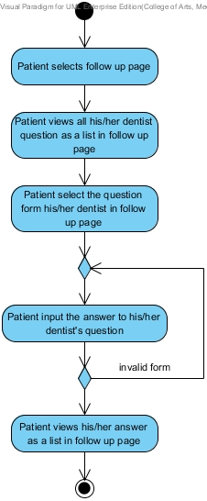

Figure 12: Answer follow up question [AD-29]

|  |  |  |  |
| --- | --- | --- | --- |
| Use Case ID: | UC-35 | | |
| Use Case Name: | Display follow up message (mobile application) | | |
| **Created By:** | Worapun Wongkium | **Last Updated By:** | Worapun Wongkium |
| **Date Created:** | 15/09/2014 | **Last Revision Date:** | 14/10/2014 |
| **Actors:** | Patient | | |
| **Description:** | Patient can view follow up massage that his/her dentist asked in mobileapplicationas a list | | |
| **Trigger:** | Patient selects follow up menu | | |
| **Preconditions:** | Patient is already logged into the mobile application by using patientID and password | | |
| **Postconditions:** | Patient can view the dentist’s follow up message as a list patient follow up page | | |
| **Normal Flow:** | 1. Patient select the follow up menu in the mobile application 2. System shall connect with the dentalclinic database 3. System shall provide the follow up page in the mobile application 4. System shall retrieve the follow up’s data including patientID, dentistID, question, answer, question time, and answer time from followup table the dentalclinic database 5. System shall provide the follow up’s data including question, answer, question time, and answer time as a list from followup table the dentalclinic database into the follow up page in mobile application 6. Patient can view all his/her dentist’s follow up message as a list in follow up pagein mobile application | | |
| **Alternative Flows:** | N/A | | |
| **Exceptions:** | System will not connect to the database and deliver information if there is no internet connection. | | |

* 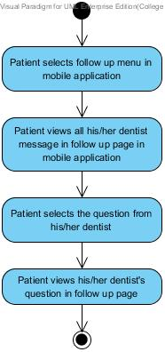
* Figure 13: Display follow up message [AD-30]

|  |  |  |  |
| --- | --- | --- | --- |
| Use Case ID: | UC-36 | | |
| Use Case Name: | Answer follow up question (mobile application) | | |
| **Created By:** | Worapun Wongkium | **Last Updated By:** | Kanokwan Maneerat |
| **Date Created:** | 15/09/2014 | **Last Revision Date:** | 19/10/2014 |
| **Actors:** | Patient | | |
| **Description:** | Patient can answer view follow up massage that his/her dentist asked inmobile applicationas a list | | |
| **Trigger:** | Patient select the question from his/her dentist for answer | | |
| **Preconditions:** | Patient is already logged into the website by using patientID and password | | |
| **Postconditions:** | Patient is already answer the question for following up with his/her dentist in follow up page | | |
| **Normal Flow:** | 1. Patient selects patient follow up page 2. System shall connect with the dentalclinic database 3. System shall provide the follow up page in the mobile application 4. System shall retrieve the follow up’s data including patientID, dentistID, question, answer, question time, and answer time from followup table the dentalclinic database 5. System shall provide the follow up’s data including question, answer, question time, and answer time as a list from followup table the dentalclinic database into the follow up page in mobile application 6. Patient select the dentist’s question to answer 7. System shall provide the answer follow up form in the follow up page in the mobile application 8. System shall provide the follow up’s data including question, answer, question time, and answer time into the answer follow up form in follow up page in the mobile application 9. Patient input the answer in the form and press submit button 10. System shall add the patient’s message data including answer into the followup database in the dentalclinic database 11. System shall update follow up table in the dentalclinic database 12. Patient enter into the patient follow up page 13. System shall retrieve the patient’s message data including the question and answer from the database 14. System shall provide the patient’s message data as a list in the follow up page in the mobile application 15. Patient can view his/her status that is the answer is posted or not 16. Patient can view his/her dentists question’s status that is dentist is already post or not | | |
| **Alternative Flows:** | 9a. Patient presses submit button and some field is empty.   1. System shall show error message “Please fill out this field” for any field that requires being not empty 2. Go back to normal flow 8   15a. Patient can view his/her status that is the answer is posted or not   1. System shall return true if the question is already save 2. System shall return false if the question is not saved yet   16a. Patient can view his/her dentists question’s status that is dentist is already post or not   1. System shall return true if the answer is already save 2. System shall return false if the answer is not saved yet | | |
| **Exceptions:** | System will not connect to the database and deliver information if there is no internet connection. | | |

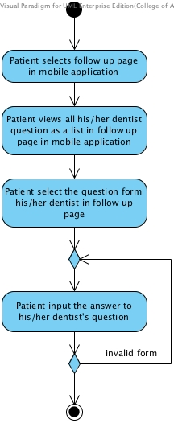

Figure 14: Answer follow up question in mobile application [AD-31]

|  |  |  |  |
| --- | --- | --- | --- |
| Use Case ID: | UC-37 | | |
| Use Case Name: | Display dental clinic information and promotion(website) | | |
| **Created By:** | Worapun Wongkium | **Last Updated By:** | Worapun Wongkium |
| **Date Created:** | 15/09/2014 | **Last Revision Date:** | 14/10/2014 |
| **Actors:** | Patient | | |
| **Description:** | Patient can view the dental clinic information in the information and promotion page in the website | | |
| **Trigger:** | Patient selects information and promotion page | | |
| **Preconditions:** | Patient enter to the dental clinic website | | |
| **Postconditions:** | Patient can view the dental clinic information in the website | | |
| **Normal Flow:** | 1. Patient selects information and promotion page 2. System shall connect with the dentalclinic database 3. System shall provide the dental clinic information and promotion page in the website 4. Patient selects some dental clinic information to view 5. System shall retrieve the dental information’s data or promotion’s data including infoID, title, and details from the information table in the dentalclinic database 6. System shall provide the dental clinic information and promotion’s data including title and details from information table in the dentallcinic database into the information and promotion page in in the website 7. Patient can view the dental clinic information in the website | | |
| **Alternative Flows:** | N/A | | |
| **Exceptions:** | System will not connect to the database and deliver information if there is no internet connection. | | |

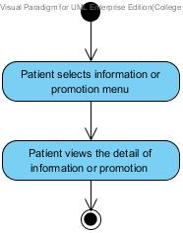

Figure 15: Display dental clinic informationand promotion in website [AD-32]

|  |  |  |  |
| --- | --- | --- | --- |
| Use Case ID: | UC-38 | | |
| Use Case Name: | Display dental clinic information and promotion (mobile application) | | |
| **Created By:** | Worapun Wongkium | **Last Updated By:** | Worapun Wongkium |
| **Date Created:** | 15/09/2014 | **Last Revision Date:** | 14/10/2014 |
| **Actors:** | Patient | | |
| **Description:** | Patient can view the dental clinic information in the information and promotion page in the mobile application | | |
| **Trigger:** | Patient selects information and promotion page | | |
| **Preconditions:** | Patient enter to the dental clinic mobile application | | |
| **Postconditions:** | Patient can view the dental clinic information in the mobile application | | |
| **Normal Flow:** | 1. Patient selects information and promotion page 2. System shall connect with the dentalclinic database 3. System shall provide the dental clinic information and promotion page in the mobile application 4. Patient selects some dental clinic information to view 5. System shall retrieve the dental information’s data or promotion’s data including infoID, title, and details from the information table in the dentalclinic database 6. System shall provide the dental clinic information and promotion’s data including title and details from information table in the dentallcinic database into the information and promotion page in the mobile application 7. Patient can view the dental clinic information in the mobile application | | |
| **Alternative Flows:** | N/A | | |
| **Exceptions:** | System will not connect to the database and deliver information if there is no internet connection. | | |

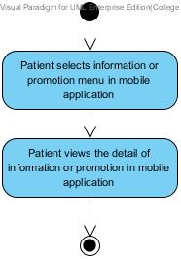

Figure 16: Display dental clinic informationand promotion in mobile application [AD-33]

|  |  |  |  |
| --- | --- | --- | --- |
| Use Case ID: | UC-39 | | |
| Use Case Name: | Add dental clinic information | | |
| **Created By:** | Worapun Wongkium | **Last Updated By:** | Worapun Wongkium |
| **Date Created:** | 15/09/2014 | **Last Revision Date:** | 14/10/2014 |
| **Actors:** | Officer | | |
| **Description:** | Officer can add new dental clinic information into the database | | |
| **Trigger:** | Officer select create dental clinic information menu | | |
| **Preconditions:** | Officer is already logged in to the website by using officerID and password | | |
| **Postconditions:** | Officer views all of the dental clinic information data as a list in all information and promotion page | | |
| **Normal Flow:** | 1. Officer selects create dental clinic information menu 2. System shall connect with the dentalclinic database 3. System shall provide the create information and promotion page 4. Officer input the dental clinic information including information topic, description into the database and press submit 5. System shall add dental clinic information’s data or promotion’s data including type,title and details into the information table in dentalclinic database 6. System shall update information table in the dentalclinic database 7. Officer enters to the all information and promotion page 8. System shall retrieve the dental information’s data or promotion’s data including infoID, title, and details from the information table in the dentalclinic database 9. System shall provide the dental information and promotion as a list including type, title and details from information table in the dentalclinic database into all information and promotion page 10. Officer can view all the dental information and promotion as a list in all information and promotion page | | |
| **Alternative Flows:** | 4a. Patient presses submit button and some field is empty.   1. System shall show error message “Please fill out this field” for any field that requires being not empty 2. Go back to normal flow 4 | | |
| **Exceptions:** | System will not connect to the database and deliver information if there is no internet connection. | | |

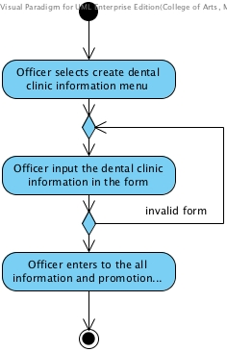

Figure 17: Add dental clinic information [AD-34]

|  |  |  |  |
| --- | --- | --- | --- |
| Use Case ID: | UC-40 | | |
| Use Case Name: | Edit dental clinic information | | |
| **Created By:** | Worapun Wongkium | **Last Updated By:** | Worapun Wongkium |
| **Date Created:** | 15/09/2014 | **Last Revision Date:** | 14/10/12014 |
| **Actors:** | Officer | | |
| **Description:** | Officer can edit the dental clinic information in the database | | |
| **Trigger:** | Officer select edit function in the all information and promotion page | | |
| **Preconditions:** | Officer is already logged in to the website by using officerID and password | | |
| **Postconditions:** | Officer views all dental clinic information as a list in all information and promotion page | | |
| **Normal Flow:** | 1. Officer selects edit function in all information and promotion page 2. System shall connect with the dentalclinic database 3. System shall retrieve the dental information’s data or promotion’s data including infoID, title, and details from the information table in the dentalclinic database 4. System shall provide the dental information’s data or promotion’s data including infoID, title, and details from the information table in the dentalclinic database into the edit information and promotion form 5. Officer input some information for editing and press submit 6. System shall edit dental clinic information’s data or promotion’s data which are type, title, and details in information and promotion table in the dentalclinic database 7. Officer redirects to the all information and promotion page 8. System shall retrieve the dental information’s data or promotion’s data including infoID, title, and details from the information table in the dentalclinic database 9. System shall provide the dental information and promotion as a list including type, title and details from information table in the dentalclinic database into all information and promotion page 10. Officer can view all the dental information and promotion as a list in all information and promotion page | | |
| **Alternative Flows:** | 5a. Patient presses submit button and some field is empty.   1. System shall show error message “Please fill out this field” for any field that requires being not empty 2. Go back to normal flow 5 | | |
| **Exceptions:** | System will not connect to the database and deliver information if there is no internet connection. | | |

* 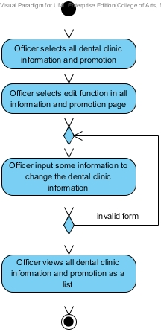

Figure 18: Edit dental clinic information [AD-35]

|  |  |  |  |
| --- | --- | --- | --- |
| Use Case ID: | UC-41 | | |
| Use Case Name: | Delete dental clinic information | | |
| **Created By:** | Worapun Wongkium | **Last Updated By:** | Worapun Wongkium |
| **Date Created:** | 15/09/2014 | **Last Revision Date:** | 14/10/2014 |
| **Actors:** | Officer | | |
| **Description:** | Officer can delete dental clinic information in the database | | |
| **Trigger:** | Officer select delete function in all information and promotion page | | |
| **Preconditions:** | Officer is already logged in to the website by using officerID and password | | |
| **Postconditions:** | Officer views all dental clinic information as a list in all information and promotion page | | |
| **Normal Flow:** | 1. Officer enter into the all information and promotion page 2. System shall connect with the dentalclinic database 3. System shall retrieve the dental clinic information data and promotion’s data including title and details from information table in the dentallcinic database 4. System shall provide the dental information and promotion as a list including title and details from information table in the dentalclinic database into all information and promotion page 5. Officer selects delete function in all information and promotion page 6. System shall delete dental clinic information’s data or promotion’s data from information in the dentallcinic database 7. System shall update information table in the dentalclinic database 8. Officer redirects to the all information and promotion page 9. System shall provide the dental information and promotion as a list in all information and promotion page 10. Officer can view all the dental information and promotion as a list in all information and promotion page | | |
| **Alternative Flows:** | N/A | | |
| **Exceptions:** | System will not connect to the database and deliver information if there is no internet connection. | | |

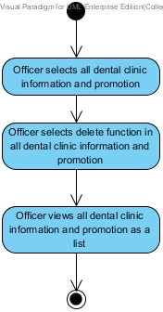

Figure 19: Delete dental clinic information [AD-36]

|  |  |  |  |
| --- | --- | --- | --- |
| Use Case ID: | UC-42 | | |
| Use Case Name: | Display dental clinic information and promotion(website) | | |
| **Created By:** | Worapun Wongkium | **Last Updated By:** | Worapun Wongkium |
| **Date Created:** | 15/09/2014 | **Last Revision Date:** | 14/10/2014 |
| **Actors:** | Visitor | | |
| **Description:** | Visitor can view the dental clinic information in the information and promotion page in the website | | |
| **Trigger:** | Visitor selects information and promotion page | | |
| **Preconditions:** | Visitor enter to the dental clinic website | | |
| **Postconditions:** | Visitor can view the dental clinic information in the website | | |
| **Normal Flow:** | 1. Visitor selects information and promotion page 2. System shall connect with the dentalclinic database 3. Visitor selects some dental clinic information to view 4. System shall retrieve the dental clinic information data and promotion’s data including title and details from information table in the dentallcinic database 5. System shall provide the dental clinic information and promotin’s data including title and details from information table in the dentallcinic database into the information and promotion page in the website 6. Visitor can view the dental clinic information in the website | | |
| **Alternative Flows:** | N/A | | |
| **Exceptions:** | System will not connect to the database and deliver information if there is no internet connection. | | |

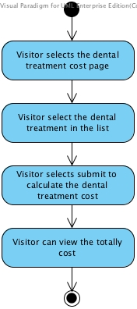

Figure 20: Display dental clinic information and promotion(website**)** [AD-37]

|  |  |  |  |
| --- | --- | --- | --- |
| Use Case ID: | UC-43 | | |
| Use Case Name: | Estimate the dental treatment cost (website) | | |
| **Created By:** | Worapun Wongkium | **Last Updated By:** | Worapun Wongkium |
| **Date Created:** | 15/09/2014 | **Last Revision Date:** | 14/10/2014 |
| **Actors:** | Patient | | |
| **Description:** | Patient can select the dental treatment to estimate the cost | | |
| **Trigger:** | Patient select the dental treatment cost page | | |
| **Preconditions:** | Patient enter to the dental clinic website | | |
| **Postconditions:** | Patient can view the totally cost that he/she selected | | |
| **Normal Flow:** | 1. Patient selects the dental treatment cost page 2. System shall connect with the dentalclinic database 3. System shall provide the cost estimation page in website 4. Patient select the dental treatment in the list 5. System shall retrieve the dental treatments’ data including treatmentID, dental treatment name, treatment cost from the treatment table in dentalclinic database 6. System shall provide the dental treatment’s data as a list including treatmentID, dental treatment name, treatment cost from the treatment table in dentalclinic database into the cost estimation page in website 7. Patient press calculate button for estimating the dental treatment cost 8. System shall calculate the cost of dental treatment by using the treatment cost that user selected 9. System shall provide the totally cost of dental treatment that the user selected in the cost estimation page 10. Patient can view the totally cost that he/she selected | | |
| **Alternative Flows:** | N/A | | |
| **Exceptions:** | System will not connect to the database and deliver information if there is no internet connection. | | |

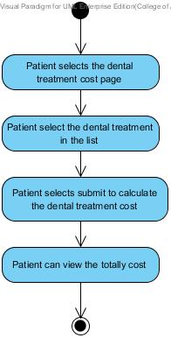

Figure 21: Estimate the dental treatment cost in website[AD-38]

|  |  |  |  |
| --- | --- | --- | --- |
| Use Case ID: | UC-44 | | |
| Use Case Name: | Estimate the dental treatment cost (mobile application) | | |
| **Created By:** | Worapun Wongkium | **Last Updated By:** | Worapun Wongkium |
| **Date Created:** | 15/09/2014 | **Last Revision Date:** | 14/10/2014 |
| **Actors:** | Patient | | |
| **Description:** | Patient can select the dental treatment to estimate the cost in the mobile application | | |
| **Trigger:** | Patient select the dental treatment cost page | | |
| **Preconditions:** | Patient enter to the dental clinic mobile application | | |
| **Postconditions:** | Patient can view the totally cost that he/she selected | | |
| **Normal Flow:** | 1. Patient selects the dental treatment cost page 2. System shall connect with the dentalclinic database 3. System shall provide the cost estimation page in mobile application 4. Patient select the dental treatment in the list 5. System shall retrieve the dental treatments’ data including treatmentID, dental treatment name, treatment cost from the treatment table in dentalclinic database 6. System shall provide the dental treatment’s data as a list including treatmentID, dental treatment name, treatment cost from the treatment table in dentalclinic database into the cost estimation page in mobile application 7. Patient press calculate button for estimating the dental treatment cost 8. System shall calculate the cost of dental treatment by using the treatment cost that user selected 9. System shall provide the totally cost of dental treatment that the user selected in the cost estimation page 10. Patient can view the totally cost that he/she selected | | |
| **Alternative Flows:** | N/A | | |
| **Exceptions:** | System will not connect to the database and deliver information if there is no internet connection. | | |

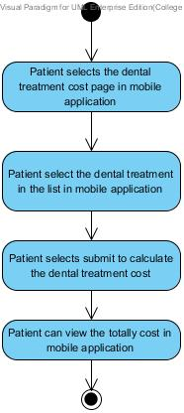

Figure 22: Estimate the dental treatment cost in mobile application[AD-39]

|  |  |  |  |
| --- | --- | --- | --- |
| Use Case ID: | UC-45 | | |
| Use Case Name: | Estimate the dental treatment cost (website) | | |
| **Created By:** | Worapun Wongkium | **Last Updated By:** | Worapun Wongkium |
| **Date Created:** | 15/09/2014 | **Last Revision Date:** | 14/10/2014 |
| **Actors:** | Visitor | | |
| **Description:** | Visitor can select the dental treatment to estimate the cost | | |
| **Trigger:** | Visitor select the dental treatment cost page | | |
| **Preconditions:** | Visitor enter to the dental clinic website | | |
| **Postconditions:** | Visitor can view the totally cost that he/she selected | | |
| **Normal Flow:** | 1. Visitor selects the dental treatment cost page 2. System shall connect with the dentalclinic database 3. System shall provide the cost estimation page in website 4. Visitor select the dental treatment in the list 5. System shall retrieve the dental treatments’ data including treatmentID, dental treatment name, treatment cost from the treatment table in dentalclinic database 6. System shall provide the dental treatment’s data as a list including treatmentID, dental treatment name, treatment cost from the treatment table in dentalclinic database into the cost estimation page in website 7. Visitor press calculate button for estimating the dental treatment cost 8. System shall calculate the cost of dental treatment by using the treatment cost that user selected 9. System shall provide the totally cost of dental treatment that the user selected in the cost estimation page 10. Visitor can view the totally cost that he/she selected | | |
| **Alternative Flows:** | N/A | | |
| **Exceptions:** | System will not connect to the database and deliver information if there is no internet connection. | | |



Figure 23: Estimate the dental treatment cost (website)[AD-40]

|  |  |  |  |
| --- | --- | --- | --- |
| Use Case ID: | UC-46 | | |
| Use Case Name: | Add dental treatment | | |
| **Created By:** | Worapun Wongkium | **Last Updated By:** | Worapun Wongkium |
| **Date Created:** | 15/09/2014 | **Last Revision Date:** | 14/10/2014 |
| **Actors:** | Officer | | |
| **Description:** | Officer can add new dental treatment into the database | | |
| **Trigger:** | Officer select create dental treatment menu | | |
| **Preconditions:** | Officer is already logged in to the website by using officerID and password | | |
| **Postconditions:** | Officer views all of the dental treatment data as a list in all dental treatment page | | |
| **Normal Flow:** | 1. Officer selects create dental clinic information menu 2. System shall connect with the dentalclinic database 3. System shall provide the create dental treatment page 4. Officer input the dental treatment including name, description, and cost into the database and press submit 5. System shall add the dental treatment information data including dental treatment name, treatment cost into the treatment table in the dentalclinic database 6. System shall update the dental treatment table in the dentalclinic database 7. Officer enters to the all dental treatment page 8. System shall retrieve the dental treatments’ data including treatmentID, dental treatment name, treatment cost from the treatment table in dentalclinic database 9. System shall provide the dental treatment data as a list in that is including with treatmentID, treatment name and treatment cost in all dental treatment pages 10. Officer can view all the dental treatment as a list in all dental treatment page | | |
| **Alternative Flows:** | 4a. Patient presses submit button and some field is empty.   1. System shall show error message “Please fill out this field” for any field that requires being not empty 2. Go back to normal flow 4 | | |
| **Exceptions:** | System will not connect to the database and deliver information if there is no internet connection. | | |

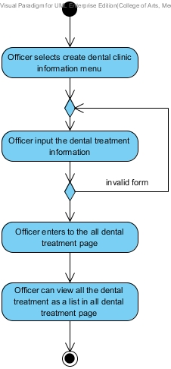

Figure 24: Add dental treatment [AD-41]

|  |  |  |  |
| --- | --- | --- | --- |
| Use Case ID: | UC-47 | | |
| Use Case Name: | Edit dental treatment | | |
| **Created By:** | Worapun Wongkium | **Last Updated By:** | Worapun Wongkium |
| **Date Created:** | 15/09/2014 | **Last Revision Date:** | 14/10/2014 |
| **Actors:** | Officer | | |
| **Description:** | Officer can edit the dental treatment in the database | | |
| **Trigger:** | Officer select edit function in the all dental treatment page | | |
| **Preconditions:** | Officer is already logged in to the website by using officerID and password | | |
| **Postconditions:** | Officer views all dental treatment as a list in all dental treatment page | | |
| **Normal Flow:** | 1. Officer selects edit function in all dental treatment page 2. System shall connect with the dentalclinic database 3. System shall retrieve the dental treatments’ data including treatmentID, dental treatment name, treatment cost from the treatment table in dentalclinic database 4. System shall provide the dental treatment data as a list in that is including with treatmentID, treatment name and treatment cost in all dental treatment pages 5. Officer change some detail in the form for editing and press submit 6. System shall provide the dental treatment’s data including treatmentID, dental treatment name, treatment cost from the treatment table in dentalclinic database into the dental treatment edit form 7. System shall edit dental treatment’s data, which are treatmentID, treatment name, treatment cost in dental treatment table in the dentalclinic database 8. Officer enter to the all dental treatment page 9. System shall retrieve the dental treatments’ data including treatmentID, dental treatment name, treatment cost from the treatment table in dentalclinic database 10. System shall provide the dental treatment data as a list in that is including with treatmentID, treatment name and treatment cost in all dental treatment pages 11. Officer can view all dental treatment as a list in all dental treatment page | | |
| **Alternative Flows:** | 5a. Patient presses submit button and some field is empty.   1. System shall show error message “Please fill out this field” for any field that requires being not empty 2. Go back to normal flow 5 | | |
| **Exceptions:** | System will not connect to the database and deliver information if there is no internet connection. | | |

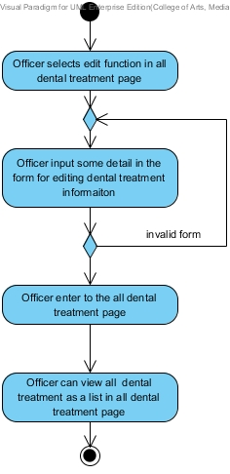

Figure 25: Edit dental treatment [AD-42]

|  |  |  |  |
| --- | --- | --- | --- |
| Use Case ID: | UC-48 | | |
| Use Case Name: | Delete dental treatment | | |
| **Created By:** | Worapun Wongkium | **Last Updated By:** | Worapun Wongkium |
| **Date Created:** | 15/09/2014 | **Last Revision Date:** | 14/10/2014 |
| **Actors:** | Officer | | |
| **Description:** | Officer can delete the dental treatment in the database | | |
| **Trigger:** | Officer select delete function in the all dental treatment page | | |
| **Preconditions:** | Officer is already logged in to the website by using officerID and password | | |
| **Postconditions:** | Officer views all dental treatment as a list in all dental treatment page | | |
| **Normal Flow:** | 1. Officer enter into the all dental treatment page 2. System shall connect with the dentalclinic database 3. System shall retrieve the dental treatments’ data including treatmentID, dental treatment name, treatment cost from the treatment table in dentalclinic database 4. System shall provide the dental treatment data as a list in that is including with treatmentID, treatment name and treatment cost in all dental treatment pages 5. Officer selects delete function in all information and promotion page 6. System shall delete dental clinic treatment’s data from dental treatment table in the dentalclinic database 7. System shall update the dental treatment table in the dentalclinic database 8. Officer enter to the all dental treatment page 9. System shall provide the dental treatment data as a list in that is including with treatmentID, treatment name and treatment cost in all dental treatment pages 10. Officer can view all the dental treatment as a list in all dental treatment page | | |
| **Alternative Flows:** | N/A | | |
| **Exceptions:** | System will not connect to the database and deliver information if there is no internet connection. | | |

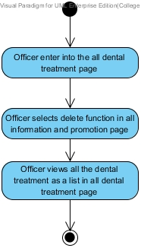

Figure 26: Delete dental treatment [AD-43]

|  |  |  |  |
| --- | --- | --- | --- |
| Use Case ID: | UC-49 | | |
| Use Case Name: | View dental treatment information | | |
| **Created By:** | Kanokwan Maneerat | **Last Updated By:** | Kanokwan Maneerat |
| **Date Created:** | 19/10/2014 | **Last Revision Date:** | 19/10/2014 |
| **Actors:** | Officer | | |
| **Description:** | Officer can view dental treatment information as a list in all treatment page | | |
| **Trigger:** | Officer select at all treatment menu | | |
| **Preconditions:** | Officer is already logged in to the website by using officerID and password | | |
| **Postconditions:** | Officer views all dental treatment as a list in all dental treatment page | | |
| **Normal Flow:** | 1. Officer select at all treatment menu 2. System shall connect with the dentalclinic database 3. System shall retrieve the dental treatments’ data including treatmentID dental treatment name, treatment cost from the treatment table in dentalclinic database 4. System shall provide the dental treatment data as a list in that is including with treatmentID, treatment name and treatment cost in all dental treatment pages 5. Officer views the treatment information as a list in all treatment page | | |
| **Alternative Flows:** | N/A | | |
| **Exceptions:** | System will not connect to the database and deliver information if there is no internet connection. | | |

### D:\from desktop\senior project\progress 2\ad\view dental treatment information.jpg

Figure 27: Delete dental treatment [AD-44]